ST. AUGUSTINE MUKUMU BOYS’ PRIMARY
MATHEMATICS ACTIVITIES
GRADE 1 END TERM EXAM TERM 1 2019

Count and write how many.
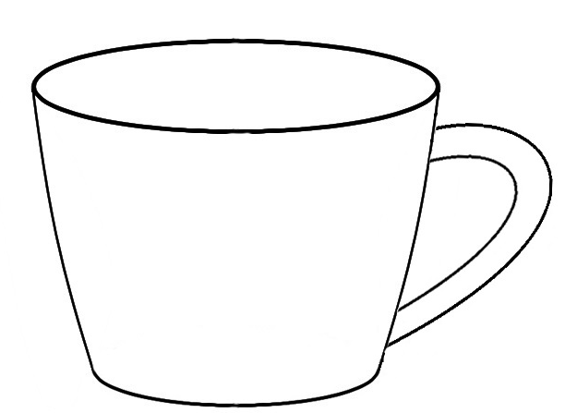

________________

_________________
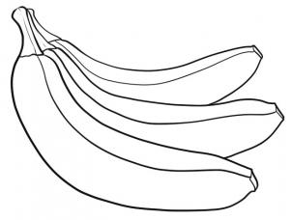

__________________

_____________________

______________________
Write in words
- ______________ 9

- ______________ 4

- ______________ 7

- ______________ 10

- ____________ 8

Add (+)
- 2 + 6 =

- 7 + 3 =

- 3 + 2 =

- 2 + 5 =

- 3
+2

Write the missing numbers
- 1, 2 ________ 4 , 5

- 1, 2, 3 _______5

Take away (-)
- 6 – 3 =

- 11 – 6 =

- 7 - 4 =

- 9 - 5 =

- 8 - 3 =

- Which one is longer?
A
B

- Which one is shorter?

- Which one holds more ___________
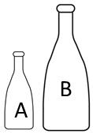

- Which one holds less?
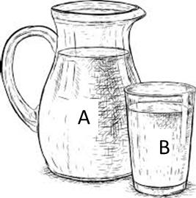

Name the shapes

____________________

_____________________

______________________
(triangle,rectangle,circle)
Add
- 5
+5

