ST. AUGUSTINE MUKUMU BOYS’ PRIMARY
MATHEMATICS ACTIVITIES
GRADE 3 END TERM EXAM TERM 1 2019

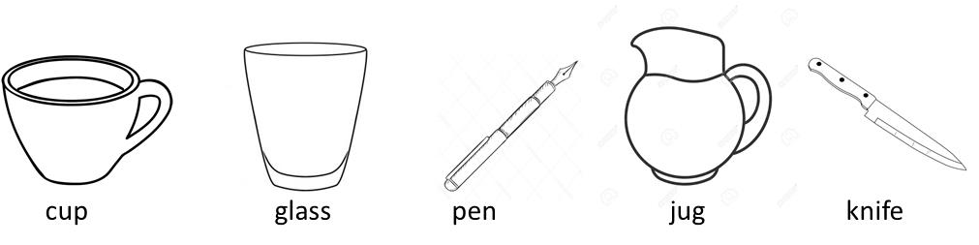

1. The pen is in the ___ position
2. The knife is in the ________ position.
3. The seventh month of the year is ____________
What is the next two numbers?
4. 998,996,994 ___________,_____________
5. =__________tens ______ ones
6. Write in words 45
________________________
7. What fraction is
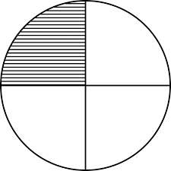

shaded._____________?
8. 791 + 7 =
9. Half of 8 is _____________
10. 246
+ 37

11. ½ or ¼ which one is bigger?______

12. 342
+ 125

13. Add using a number line
3 + 4 + 2 =

14. 79 – 5 =

15. 87
- 9

16. 7 + 7 + 7 = ____ x_____=
17. 6 x _______ = 24

18. Draw a clock showing half past 2 o’clock

19. 20 ÷ 4 = ___________

20. Which one is heavy 1kg of sand and 1kg of feathers?__________

21. We measure length in ___________ (metres, litres)
22. 5
X 7

23. 74
- 58

24. Ouma had 83 bananas to sell. Seventeen bananas were spoilt. How many bananas did he sell. ____________
25 Arrange in order from smallest to biggest 300.350,320,315, 209
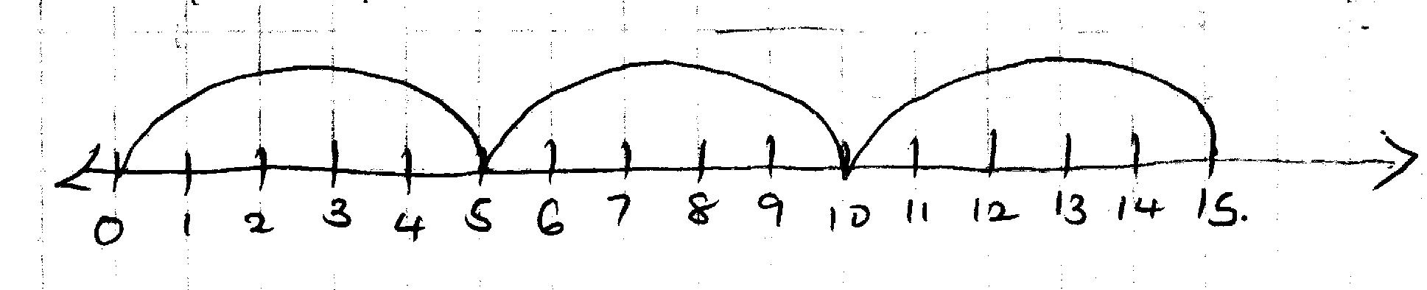
26.

________÷ ______ = _______

27. 7x10 =______________

28. __________ = 3 tens 7 ones

29. A quarter of 32 is _______

30. Ten cows have _______tails.

