GR

EVALUATION TEST TERM III -2020

SCIENCE STD SEVEN (7) Time : 1 hr 40

1. The best method of controlling both ticks and tapeworms in a farm animals would be
2. Deworming
3. Dipping
4. Spraying
5. Rotational grazing
6. Which among the following is Transparent?
7. Mirror B. Kerosene

C. Milk D. Frosted glass

1. Which plant depends on animals directly for nutrients.
2. Sundew and pitcher plant
3. Maize and Beans
4. Sundew and maize
5. Beans and pitcher plant
6. Which of the following statement is false about HIV/AIDS.
7. People with HIV have AIDS
8. White blood cells are destroyed by AIDS virus
9. Incubation stage lasts for about 12 years.
10. HIV test helps to know how many people are suffering.
11. Water can be conserved by using it sparingly in the following ways **EXCEPT**
12. Closing taps when not in use
13. Drip irrigation.
14. Repairing leaking pipes.
15. Re-using dirty water.
16. Rivers are **least** polluted by __
17. Oil spillage
18. Raw sewage
19. Industrial waste
20. Floods
21. The removal of an infected parts of a plant from a growing plant is ___
22. Weeding B. Prunning

C. Trapping D. Scaring

1. Which one is an inter dependence between plants and Animals.
2. Habitat B. Shade

C. Support D. Shelter

1. Which blood component is marked Q?

**Q**

1. Platelets
2. Red blood cells
3. White blood cells
4. Plasma
5. Which blood vessel carries deoxygenated blood into the heart.
6. Venacava
7. Pulmonary artery
8. Aorta
9. Pulmonary vein.
10. Which of the following physical changes are correctly grouped for boys and girls?

**BOYS GIRLS**

1. Wet dreams voice deepens
2. Menstruation wet dreams
3. Broad chest menstruation
4. Enlarged breast Hair on the face

1. Which parts of reproductive system produce sex cells in boys and girls.
2. Ovary and penis
3. Vagina and tests
4. Ovary and urethra
5. Testis and ovary
6. Exchange of gases takes place in the ____
7. Nose B. Lungs

C. Trachea D. Diaphragm

1. Which part of digestion system is **CORRECTLY** matched with its function?
2. Mouth kills germs
3. Duodenum produce digestive juice
4. Small intestine absorption of food
5. Stomach stores food
6. Std 4 pupils were given the following teeth.

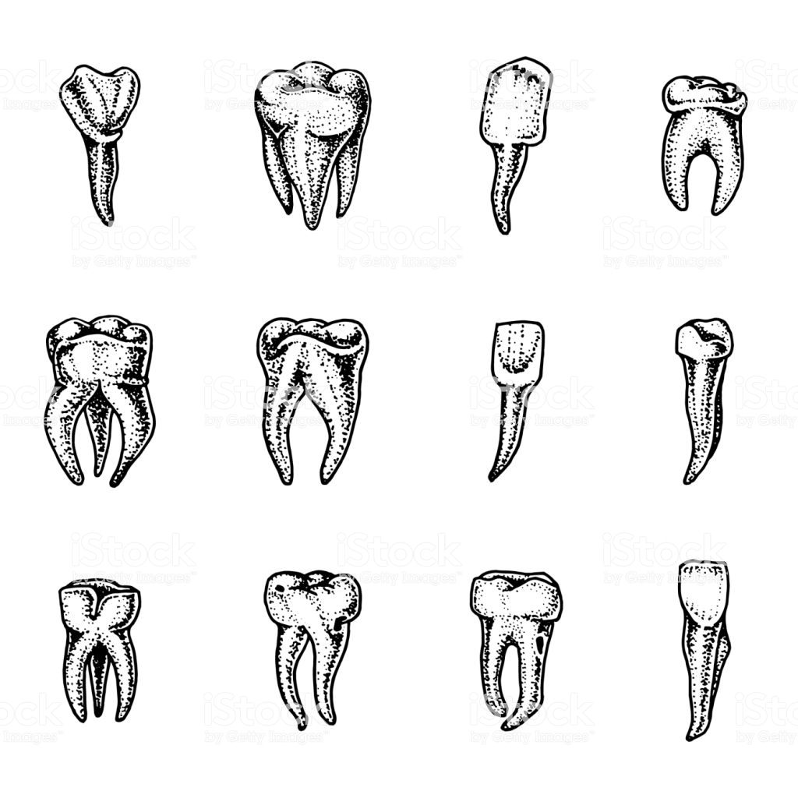

**P Q R S**

Which two types of teeth labeled P,Q,R and S are equal in number.

1. P and Q
2. Q and R
3. R and S
4. P and S
5. The surrounding of an organism is called ___
6. Shelter B. Support

C. Habitat D. Environment

1. Oxygen in the air is produced by ___
2. Soil B. Water

C. Plants D. Animals

1. The main component of the environment that is living is ___
2. Mushroom B. Soil

C. Air D. Water

1. The major environment for fish is _
2. Water and air
3. Soil and air
4. Water and plants
5. Plants and soil.
6. Which effect of water pollution reduces the number of animals in water.
7. Farm land
8. Carwash
9. Industries
10. Human waste.
11. Which water borne disease is **NOT** controlled by drinking treated water?
12. Bilharzia B. Malaria

C. Typhoid D. Cholera

1. The following are uses of water.
2. Swimming
3. Cooking
4. Fountain
5. Fishing

Which pair of uses are Recreational

1. (i) and (ii) B. (ii) and (iii)

C. (iii) and (iv) D. (i) and (iv)

1. Which immunisable disease is correctly matched with the age of a administration.

**BIRTH** **9 MONTH**

1. Polio measles
2. Tetanus yellow fever
3. Tuberculosis hepatitis B
4. Whooping cough yellow fever.
5. Which one is NOT a mistake when modeling the solar system.
6. Placing two balls on the same circle.
7. Modeling balls of different sizes
8. Drawing 9 circles
9. Mounting planets using cellotape.
10. Which drug directly affects others members of the family if abused in their presence?
11. Alcohol
12. Tobacco

C. Miraa

D. Cobblers glue

1. Which tooth problem is prevented by eating a balanced diet.
2. Tooth cavity
3. Tooth decay
4. Bleeding gum
5. Bad smell.
6. Which plant stores food in the same part as a sugarcane.
7. Irish potato
8. Onion
9. Cassava
10. Cabbage
11. In a container with boiled water, oil and seeds the pupils an investigation if
12. Water is needed for seed germination.
13. Air is needed for seed germination
14. Warmth is needed for seed germination.
15. Oil is needed for seed germination.
16. Which one produces electricity in the same as a dry cell.
17. Panel
18. Dynamo

C. Car battery

D. Hydroelectricity.

1. Which bulb will light?

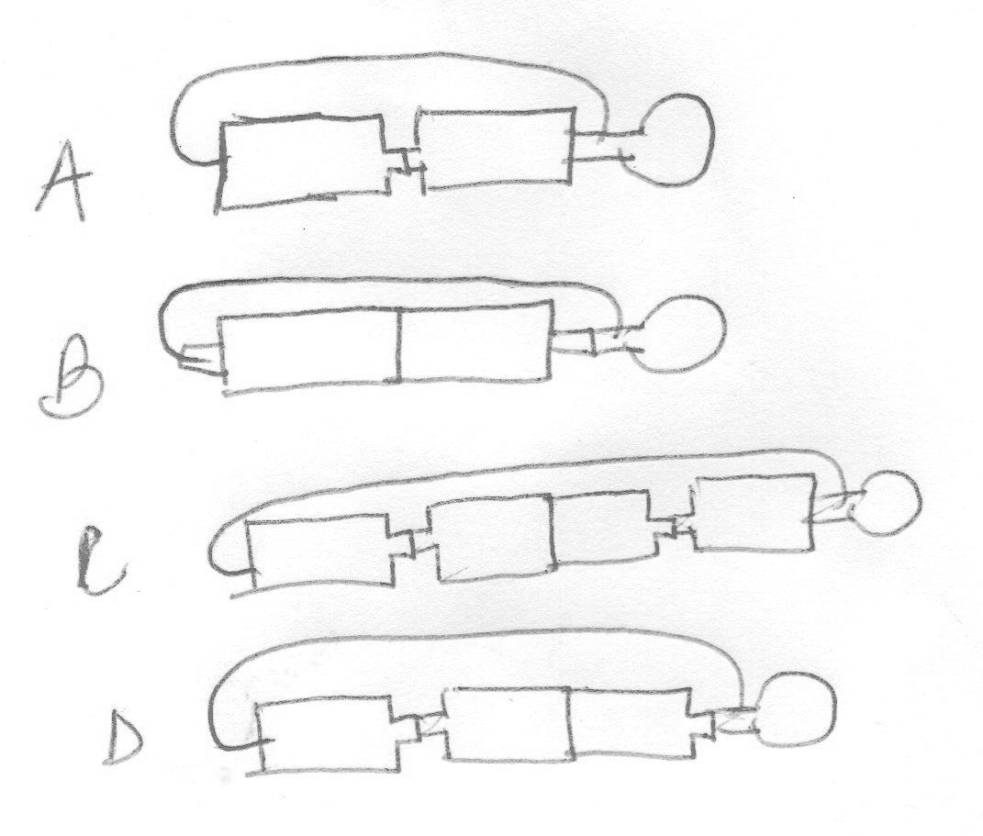

1. Poor conductors of electricity are used for making.
2. Sufuria
3. Handles of screw driver
4. Woolen clothing
5. Electric wires
6. Metallic arrestors on tall building are useful for___
7. Trapping lightning
8. Strengthening walls
9. Improving Television signals
10. Giving room for expansion
11. Pupils brought the following materials to make rainbow.
12. White paper
13. Water
14. Basin

Which material was missing?

1. String
2. Colours
3. Mirror
4. Plate.
5. Which of the following pipes will std 6 pupils see the candle flame?

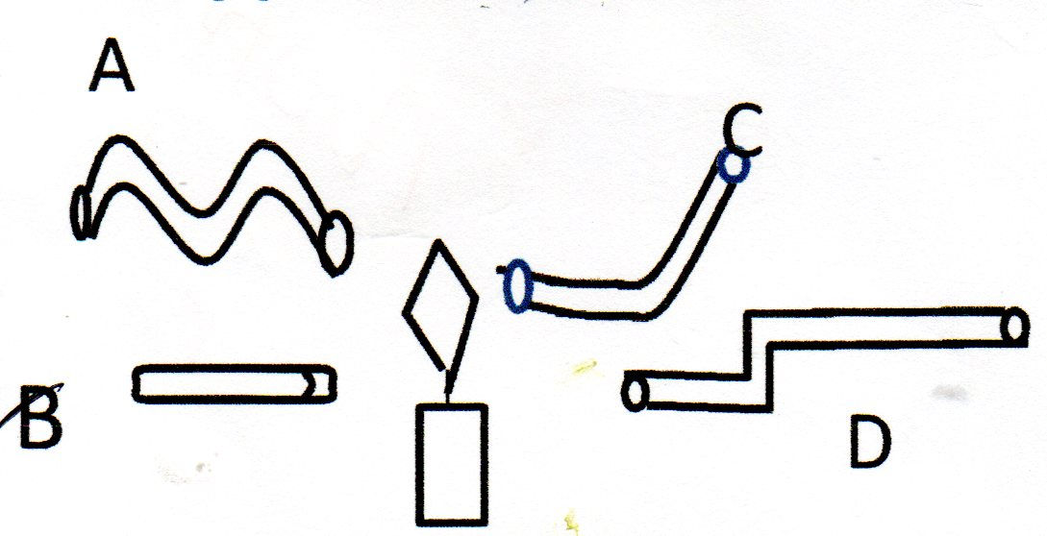

B

1. Light is used for ____
2. Seeing
3. Warming

C. Cooking

D. Food preservation.

1. Heat transfer that makes the wax to melt is



Wax

PIN

1. Conducting only
2. Radiation only
3. Convection and radiation
4. Conduction and radiation.
5. Which animal is correctly matched with their body cover.
6. Bat feathers
7. Whale scales
8. Frog scales
9. Platypus hair
10. Mutton and milk are produced by _
11. Sheep
12. Goat

C. Cattle

D. Poultry

1. Lucern provides animals with ___
2. Vitamin
3. Mineral
4. Protein
5. Carbohydrates
6. Which one is an external parasites
7. Roundworm
8. Flea
9. Liver fluke
10. Hookworm
11. Which material is magnetic?
12. Plastic
13. Aluminium

C. Copper

D. Needle

1. Which one consists of solvents only?
2. Sugar, salt, glucose
3. Water, milk, juice
4. Sugar, salt, milk
5. Water, salt, glucose
6. Which two methods of separation is only one substance recovered.
7. Winnowing and evaporation
8. Evaporation and decantation
9. Decantation and filtration.
10. Winnowing and use of a magnet.
11. Which manure takes the longest time to release nutrients to crops.
12. Organic mulches
13. Compost manure
14. Green manure
15. Farm yard manure
16. Which type of erosion forms __
17. Wavy channels
18. V-U- shaped channels
19. Shallow channels
20. Narrow channels
21. Sheet
22. Gulley

C. Rill

D. Splash

1. Which one is NOT measured in Newtons____
2. Pressure
3. Weight
4. Load
5. Friction
6. Name the following position of the drawn level.

Z

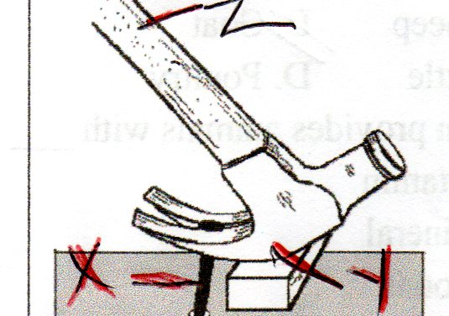

Y

X

**X Y Z**

1. Load effort fulcrum
2. Fulcrum load effort
3. Effort fulcrum load
4. Load fulcrum effort
5. Which food below provides energy?
6. Butter and coconut
7. Maize and mango
8. Honey and beans
9. Meat and rice
10. Which method of food preservation belongs in the same groups as smoking
11. Canning and freezing
12. Freezing and salting
13. Salting and drying
14. Honey and canning
15. The tube used for making water thermometer should be ___
16. Narrow and transparent
17. Narrow and opaque
18. Wide and opaque
19. Wide and transparent