SHINYALU SOUTH CLUSTER

EVALUATION TEST TERM III -2019
SSRE STD SEVEN (7)
Times: 2 hrs 15 Mins
_________________________________________________________________________________
KILIMO AREA

SCALE
0
1
2
3
4
5
6
7
8
9
Km
10
N
TB
CC
Dairy Farm
Coffee Plantation
Tea Plantation
Tea Factory
TB
Paddy field
SCH
PS
CC
ACC
Mayoni Market
Kilimo Market
PO
KILIMO TOWN
Creamery
FT
FT
Ginnery
Cotton farm
Lake Kitwe
R. TARU
KEY
Forest
Tarmac road
Murrum road
Bridge
Telephone booster
School
Temple
Fish trap
Chief’s Camp
Police station
Assistant County Commissioner
Post Office
Houses
SCH
CC
PS
ACC
PO

R. SUYA

- The lowest point in Kilimo area is likely to be at ______
- Lake Katwe.
- The tea plantation.
- Kilimo market.
- The dairy farm.
- Kilimo residents are likely to be __
- Pagans B. Muslims
C. Christians D. Hindus
- The climate around Lake Katwe is likely to be _____
- Hot and dry. B. Hot and wet.
C. Cool and wet. D. Cool and dry.
- The feature formed by Rivers Taru and Suya is called _______
- Atributary B. A junction
C. A confluence D. An estuary
- It is true to say that ______
- River Taru is a seasonal river.
- Industries in Kilimo area are primary industries.
- Kilimo residents practice lumbering as an economic activity.
- River Taru flows from the North West.
- The type of settlement in Kilimo area is _
- Linear B. Clustered
C. Dense D. Dispersed
- Kilimo area is an administrstive unit called a ______
- Division B. County
C. Sub-county D. Location
- Which one of the following cultural practices did the Bantu learn from the Cushites?
- Polygamy B. Naming
C. Circumcision D. Cultivation
- Who were the Wanyamphala in the Nyamwezi chiefdom?
- The mercenary.
- Religious leaders.
- Council of elders.
- Chiefs.
- Which one of the following forms of transport is used to transport heavy bulky goods between continents?
- Water transport.
- Railway transport.
- Air transport.
- Road transport.
- When do farmers prepare land for planting?
- Just before the rains come.
- During the rainy weather.
- As soon as the rain comes.
- When it is very cold.
- Who among the early visitors fought against slave trade in Eastern Africa?
- Carl Peters.
- B. John Speke.
C. Seyyid Said.
D. David Livingstone.
- Which one of the following is not true about age-sets in Traditional African Societies?
- They comprised of people who were initiated together.
- They comprised of people who were seen as brothers.
- They were made up of people who were born around the same time.
- They married each others sisters.
- What is not common about the Iteso, Maasai, Kipsigis and the Luo?
- They share a common origin
- They were all originally pastoralists.
- They followed the Nile during their migration.
- They are Cushites.
- The statements below describe a certain traditional system of government.
- It was located North West of Lake Victoria.
- It declined when colonialists came.
- It had a traditional parliament and a Prime Minister.
The description above best suits the
- Ameru B.Nyamwezi
C. Baganda D. Bowanga.
- The main reason why pastoral communities live in temporary shelters is that ____
- They do not have the skills to build.
- The only material found there are mud and cowdung.
- They live a nomadic lifestyle.
- The climate discourages them to have permanent shelters.
Use the diagram below to answer questions 17, 18 and 19.
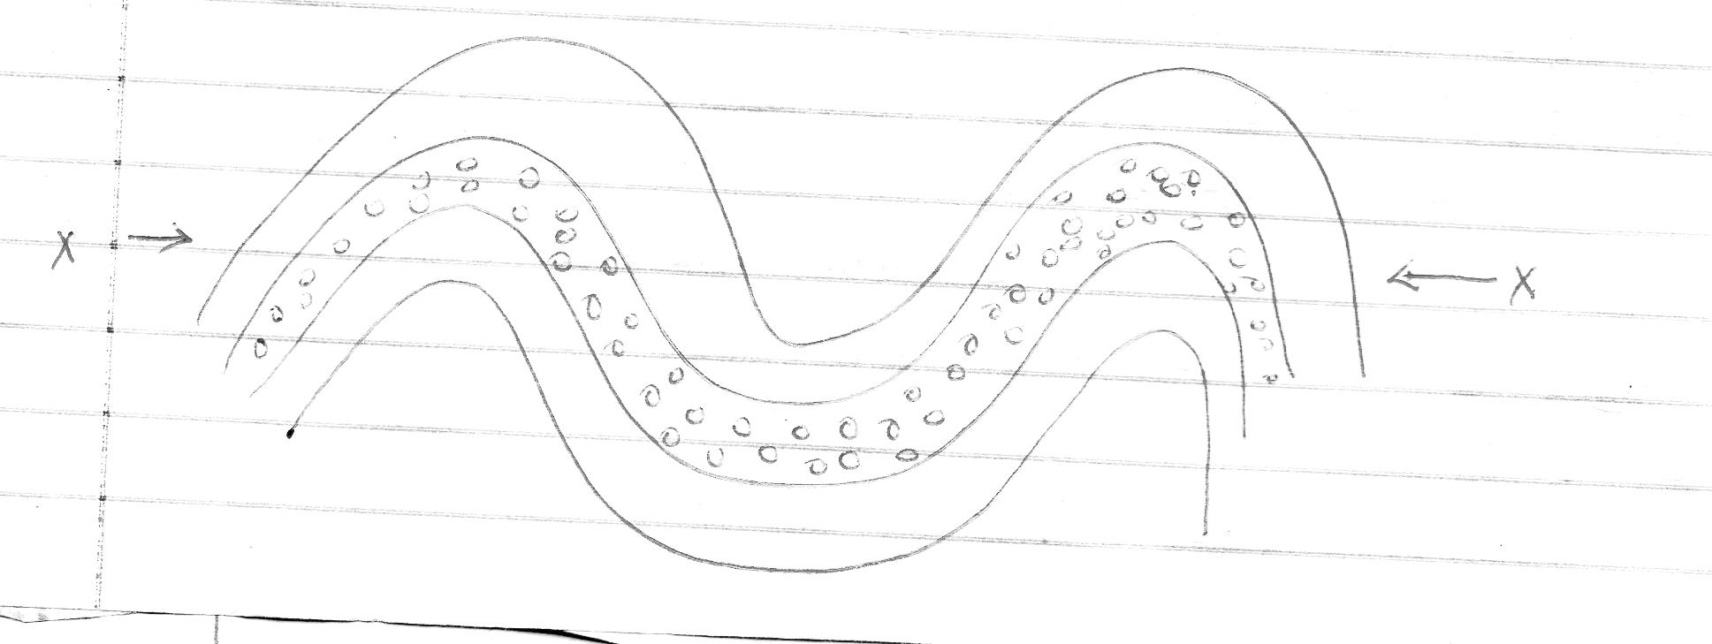

X

- The diagram above shows the formation of
- Fold mountain. B. Rift valley.
C. Fault mountain D. Volcanic mountain.
- The forces marked X are called___
- Tensional forces B. Compressional forces
C. Expansion forces D. Pushing forces.
- Which one of the following pairs of features was not formed through the above process?
- A haggar and Tibesti
- Table Mountains and Akwampim
- Atlas and Cape Ranges
- Drakensbergs and Cape Ranges.
- Which one of the following groups of communities found in West Africa is made up of Afro-Asiatic speakers only?
- Soninke, Malinke, Susu.
- Tuareg, Hausa, Andarawa
- Fulani, Wolof, Temme.
- Mosi, Gurma, Dagomba.
- Which one of the following is a manufacturing industry?
- Milk factory in Naivasha.
- Fruit canning in Thika.
- Sugarcane Milling at Butali.
- The cement factory at Bamburi.
- Which one of the following minerals is correctly matched with the way it is mined?
- Diatomite – drilling
- Fluorspar – panning
- Soda ash – dredging
- Crude oil – evarporation.
- The main reason for establishing the Kariba dam project was to ___
- Regulate the flow of river Zambezi.
- Produce hydro-electric power.
- Put more land under cultivation.
- Create a lake to attract tourists.
- The constitution of Kenya is divided into ___ chapters.
- 18 B. 12 C. 27 D. 20
- The main economic reason for the scramble of Africa was __
- To control the source of River Nile.
- To search for market for manufactured goods.
- To settle surplus population.
- To search for raw materials.
- Which one of the following weather instruments is correctly matched with the element of weather it measures?
- Barometer – Air pressure.
- Anemometer – Wind speed
- Thermometer – Wind strength.
- Windvane – Hotness or Coldness of the atmosphere.
- The main reason why the use of drugs should be discouraged is because it ____
- Results in wastage of money.
- Affects the health of the user negatively.
- Leads to school dropouts.
- Leads to family break-ups.
- Which one of the following reasons would not lead to a by-election?
- If the parliament is dissolved.
- If an MP dies
- If an MP misses eight consecutive sittings
- If an MP is jailed for more than six months.
- Three of the following are elements of good citizenship in Kenya. Which one is not?
- Participating in elections.
- Participating in mob justice
- Obeying the laws of the county.
- Respecting other people and their property.
Use the map of Africa below to answer question 31-34
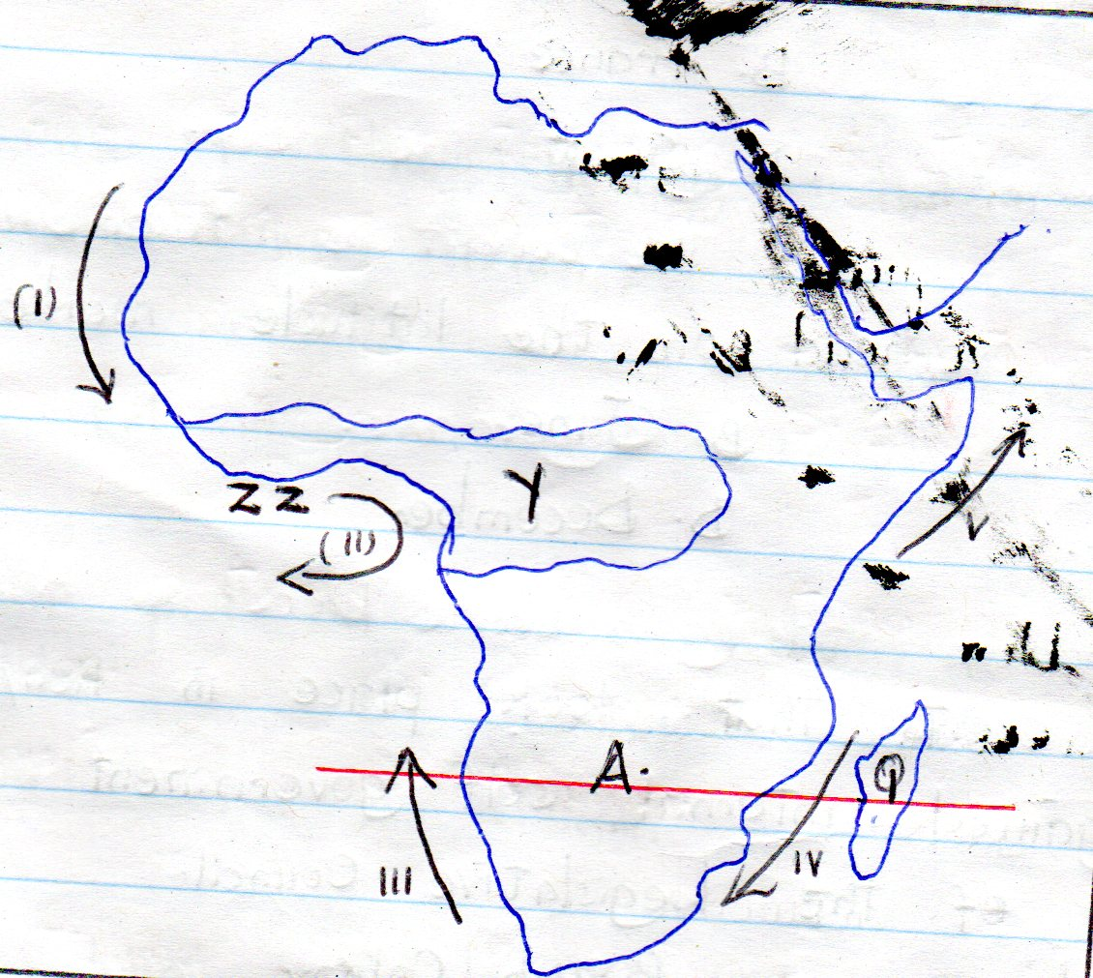
N

- Which one of the following economic activities is practiced in the area marked ZZ?
- Fishing B. Pastoralism
C. Mining D. Forestry
- (i) Skies are generally clear.
(ii) Convectional rainfall is experienced
(iii) Rain is experienced during winter.
(iv) High humidity.
- Dust storms are common.
Which one of the above characteristics best suits the climatic region marked Y?
- (i), (ii), (iii)
- (ii), (iii), (iv)
- (ii), (iv), (v)
- (iv), (v), (vi)
- Which one of the following pairs is made up of warm ocean currents only?
- (ii), (v) B. (iv), (iii)
C. (i), (iii) D. (i), (v)
- The country marked Q was colonized by _____
- Britain B. France
C. Portugal D. Spain
- The sun is overhead on the latitude marked A in __
- March B. June
C. September D. December
- Below are events that took place in Kenya.
(i) Kenya gained internal self
government.
(ii) Formation of the Legislative
council.
(iii) Kenya became a British Colony.
(iv) Kenya was declared a British
protectorate.
Which one of the following events happed first?
- (i) B. (ii) C. (iii) D. (iv)
- Which of the following did Julius Nyerere and Haile Selassie have in common?
- Both were the first president of their countries.
- Both were founder members of OAU.
- Both favoured equal distribution of resources to all people.
- Each was voted for by majority of the people to become a leader.
- Which of the following are electronic means of communication?
- Radio and newspapers.
- Radio and television.
- Cellphones and newspapers.
- Newspapers and magazines.
- Which one of the following is not a symbol of National unity?
- The constitution .
- The public seal.
- The National Anthem
- The coat of Arms.
- Which one of the following industries can be classified as a manufacturing industry?
- Petroleum refining.
- Leather tanning.
- Tyre retreading.
- Glass making.
- The main port on Lake Victoria is ___
- Entebbe B. Bukoba
C. Kisumu D. Musoma.
- Marine fishing in Kenya and Tanzania is carried out in ____
- Lake Victoria
- The Red Sea
- The Indian Ocean
- Lake Tanganyika
- Three of the following roles are played by the community in the development of the school. Which one is not?
- Donating land to the school.
- Buying books for the school.
- Teaching children.
- Providing labour to the school.
- Which one of the following countries does not border the Atlantic Ocean?
- Nigeria B. Namibia
C. Senegal D. Mozambique.
- Below are conditions necessary for the growth of a certain crop in Africa.
- Plenty of rainfall that is well
distributed throughout the year- about 1500mm to 2000mm.
- High temperatures of between
270C and 300C
(iii) Deep fertile soil
(iv) High humidity throughout the
year.
Which crop requires the conditions described above?
- Cocoa B. Cloves
C. Bananas D. Sugarcane
- The main problem facing trade blocks in Africa is ____
- Lack of a common currency
- Language barrier.
- Poor transport network
- Production of similar goods.
- Which one of the following is an import into Kenya?
- Electronics B. Soda ash
C. Tea D. Flowers
- Which one of the following ways was not used to teach the youth in Traditional African Society?
- Reading B. Apprenticeship
C. Story telling D. Ceremonies
- The best way of conserving wildlife is by _____
- Establishing animal orphanages
- Erecting electrical fences around game parks.
- Creating laws that protect wildlife.
- Educating people on the importance of wildlife.
- The drug that is most commonly abused is
- Alcohol B. Tabacco
C. Bhang D. Cocaine
- Which one of the following is not a form of child abuse?
- Asking children to clean the environment
- Exposing children to places where alcohol is sold.
- Use of harsh and abusive language against a child.
- Sending children to work for money.
- Which one of the following is the main reason why the Bantu migrated from the Congo Basin?
- Spirit of adventure
- Need for fertile farming land.
- Outbreak of diseases.
- External attacks from neighbours.
- The statements below describe a town in Eastern Africa __
- It is a capital city
- It is the headquarters of the African union.
- It is an industrial centre.
The town described above is likely to be _
- Nairobi B. Dodoma
C. Addis Ababa D. Kampala
- An election petition against an Mp is launched ______
- When electioneering
- During elections
- Before elections
- After elections.
- Which one of the following does not promote National unity?
- Games and sports
- National curriculum
- National language
- Ethnic political parties.
- Who became the president of Kenya when the country became a republic in 1964?
- Jomo Kenyatta B, Mwai Kibaki
C. Oginga Odinga D. Daniel Arap Moi.
- The following are human rights. Which one is enjoyed by school pupils?
- Right to vote.
- Right to marry.
- Right to be employed.
- Right to leisure.
- The political party that led Zimbabwe to independence in 1980 was ____
- ZANU B. ZANU P.F
C. ZAPU D. ANC
- The chief legal advisor to the government of Kenya is the ____
- President B. Chief Justice
C. Attorney General D. Principal secretary
- The second highest court in Kenya is _
- Supreme court B. Court of Appeal
C. High court D. Magistrate court.
- A situation where days and nights are almost equal is known as
- Solstice B. Hemisphere
C. Tropics D. Equinox

CRE

- According to the Genesis story of creation, human beings are special creatures mainly because they were
A. Given authority over all creation
B. Created in God’s likeness
C. Moulded from clay
D. Commanded to have children.
- During the days of Noah God punished people for their wickedness by use of ___
A. An earthquake B. Famine
C. Thunder D. Floods
- Which promise did God make to Abraham?
A. I will not destroy the earth with water again.
B. I will make you wise.
C. You will have many descendants.
D. I will give you an everlasting kingdom.
- Joseph became a famous man in the land of Egypt mainly because he was ____
A. Courageous B. Forgiving
C. Hardworking D. Faithful.
- The commandment which teaches us about respect for marriage is _
A. “Do not commit adultery”
B. “Do not steal”
C. “do not commit murder”
D. “do not accuse anyone falsely”
- ___ the king disobeyed God’s command to kill all the animals captured in war.
A. Jeroboam B. Ahab C. Saul D. Solomon
- King David is MOSTLY remembered in Isarael for ___
A. Bringing the covenant box to Jerusalem.
B. Destroying the alters of Baal
C. Building a temple for God in Jerusalem.
D. Writing the first books of the Bible.
- A miracle that was performed by both prophets Elijah and Elisha is _
A. The multiplication of oil.
B. Raising the son of the Shunamite woman.
C. Purification of water.
D. Bringing down fire from heaven.
- Who among the following people was a judge in Israel?
A. Ruth B. Hannah
C. Deborah D. Zipporah
- The birth of John the Baptist was special because ___
A. His father had doubted the angel’s message.
B. His father was a priest.
C. It had been announced by an angel.
D. He prepared the way for Jesus.
- When Jesus was twelve years old, he accompanied his parents to the city of Jerusalem for ____
A. A get together party.
B. A wedding ceremony.
C. The Passover feast.
D. Circumcision rites of passage.
- The first disciples who were called by Jesus were ____
A. James and Peter.
B. Peter and Andrew.
C. Philip and Mathew
D. Bartholomeus and Judas.
- The temptations of Jesus in the desert teaches Christians that they should___
A. Seek earthly riches.
B. Do the will of God.
C. Run away from trials.
D. Look for food when hungry.
- The miracle of Jesus to show that He had power to control nature was
A.Healing the man with the evil spirit.
B.Calming the storm.
C.Raising Lazarus.
D.Healing the Paralytic man.
- _____ was raised from the dead by Jesus.
A. Mary Magdalene. B. Martha.
C. Nicodemus. D. Jairus daughter.
- Which one of the following parables of Jesus teaches about prayer? The parable of
A. The friend at midnight.
B. The sower.
C. The prodigal son.
D. The good Samaritan.
- During the day of Pentecost ___
A.Jesus ascended to heaven.
B.The disciples spoke in many tongues.
C.People with demons were liberated.
D.Tongues of fine appeared on each disciples hand’s.
- Who among the following people helped Jesus to carry the cross?
A. Joseph of Arimathea. B. Simon of Cyrene.
C. Simon Peter. D. Nicodemus.
- ___ was the first Christian Martyr.
A. Philip Paul B. James
C. Stephen. D. John
- The seven deacons were chosen MAINLY in order to ____
A. Place hands on people and pray for them.
B. Interpret the scriptures.
C. Preach the gospel of Jesus Christ
D. Distribute food and money to the widows.
- ____ is referred to as the ‘Apostle to the Gentiles’ in the New Testament.
A. James B. Mathew
C. Paul D. John.
- _____ is a rite of passage in Traditional African Society.
A. Marriage B. Baptism
C. Pregnancy D. Confirmation.
- Kenneth visits the sick and gives them food. The fruit of the Holy Spirit he demonstrates is ___
A. Patience B. Kindness
C. Joy D. Peace.
- Which disciple was chosen to replace Judas Iscariot? Acts 1:26.
A. Mathew B. Paul C. Joseph D. Mathias.
- Which one of the following actions by Christians BEST show their respect for leaders?
A. Paying visits
B. Offering gifts
C. Correcting the leaders
D. Being obedient.
- Which one of the following organizations takes care of refugees?
A. UNICEF B.UNDP C.UNHCR D. KACA
- Which one of the following is the most important quality of prayer?
A. Privacy.
B. Short and meaningful
C. Humility.
D. Should be loud and clear.
- The best way Christians can help to reduce the spread of HIV/AIDS is by ___
A. Teaching on behaviour change
B. Being role models.
C. Providing drugs.
D. Counseling the sick.
- Which one of the following practices by Christians best shows how they can help in maintaining peace in the community?
A. Helping the needy.
B. Reporting law breakers to the authorities
C. Preaching against evil.
D. Obeying the laws of the land.
- The religious organization that started the first mission school at Rabai was ___
A. Holy Ghost Fathers.
B. Seventh Day Adventist.
C. Church Missionary Society.
D. Friends Mission Society.

