GROUP

**MATHEMATICS 2020 STD 7 Time: 2 Hours**

1. What is three hundred and thirteen thousand one hundred and one in symbols
2. 3130101 B. 3013101
3. 313101 D. 31301
4. Three people shared 15.42kg of sugar equaly. How much sugar did each get
5. 4.15kg B. 4.51kg

C. 5.14kg D. 5.41kg

1. Evaluate (8.25-1.05) + 3.6
2. 10.8 B. 8.0

C. 7.20 D. 20

1. Cherop ran around the field shown ten times. What distance did she cover in km

63M

Π =22/7

97 M

1. 1.98km B. 3.29km

C. 3.90km D. 3.92km

1. What is the next number in the pattern

7 ,12 ,19 ,30 ,43 ________

1. 47 B. 49

C. 60 D. 67

1. Convert 5.75 to a fraction and give your answer in simplest form
2. 51/4 B. 51/2

C. 53/4 D. 575/100

1. A rectangular tank is 75cm long 50cm wide and 32cm high.how many litres can it hold when full?
2. 120,000 B. 12,000

C. 1200 D. 120

1. In a month of July George made profit of 12,000 in August the profit reduced to Ksh.8,000/= What was the percentage decrease?
2. $662/3$ B. 50%

C $.33 1/3$ D. 20%

1. In the number 208764 the total value of 8 is added to the total value of 6. Which of the following is the correct answer
2. 80060 B. 8060

C. 806 D. 86

1. Work out

1/4÷1/2 of 1/2+(2/3-1/6)

1. 11/2 B. 11/6

C. ¾ D. 9/16

1. The perimeter of a rectangular plot is 57.98m. if the width of the plot is 8.6m. what is its length.
2. 20.39m B. 24.39m

C 40.78m D. 49.38m

1. Joy sold milk from 8th December 2011 to 8th march 2012. How many days did she sell the milk
2. 90 B. 91

C. 92 D. 93

1. Calculate the LCM OF 36 40 AND 144
2. 4 B. 30 C. 180 D. 720
3. Calculate the area of the figure below which is made up of a quarter circle, triangle and rectangle π =22/7

7M

1. 128cm2
2. 186.5cm2
3. 196.5cm 2

8M

1. 210cm2

15m

1. Solve the equation 4(3y-5) = 2(3y-4)
2. 1.5 B. 2 C. 2.5 D. 8
3. Omollo deposited ksh. 80,000 in a bank which pays simple interest at rate of 10% per annum. Calculate the total amount he had in his account after 3 years.
4. 24,000 B. 94,000

C. 104,000 D. 140,000

1. A cylindrical tank of diameter 5.6cm and height 4m is half full of water. Calculate the amount of water needed to fill the tank

π = 31/7

1. 98560L C. 49280L
2. 89500L D. 48920L
3. In the figure, line SR is parallel to line TU. While line ST is parallel to UV. Line OS=OT angle RST (<RST)= 42°

R

T

420

S

O

V

U

What is the size of angle TOV

1. 138° C. 840
2. 96° D. 480
3. hat is the sum of the verticles and faces of the rectangular prism shown below

E

A

B

F

1. 11 B. 10 C. 8 D. 7
2. Wangoli collects 150 eggs daily from her farm. She sells each egg at sh. 9 to a retailer who sells each egg at sh. 11.how much profit did the retailer make in the month of april 2019
3. 19000 B. 9000

C. 1900 D. 1500

1. The population of Heca school was 900. The ratio of boys to girls was 5 : 4 . one day 5% of the girls and 2% of the boys were absent. How many pupils were present
2. 870 B. 867

C. 837 D. 603

1. What is place of digit 7 in16.05 ÷ 15
2. Ones B. Tens

C. Tenths D. hundredths

1. in the figure below is a circle inscribed in a semi circle . part of the figure is shaded and o is the centre of the circle.

4M

π= 3.14

Find the area of the shaded part.

1. 1.57 B. 4.71

C. 6.28 D. 9.42

1. Okome ,jombi,and shikwati shared a piece of land. Okome got 0.45 of the land,jombi got 0.3 and shikwati got the rest. How large was Okome’s share if shikwati got 2hecters
2. 8 B. 6 C. 3.6 D. 2.4
3. What is the value of

0.124 X 38.4 X 1.1

0.32 X 6.2

1. 264 B. 26.4

C. 2.64 D. 0.264

1. Zainabu bought five sacks of carrot for 13500 .each sack weighed 90kg. how much she sell each kg to make 20% profit.
2. 40 C. 33
3. 36 D. 30
4. From Kisumu to Kakamega is 63km.ochieng cycled the distance in 3hrs. calculate his speed in m/s
5. 55/6m/s C. 42/3m/s
6. 5m/s D. 4m/s
7. In a test marked out of 20 five students scored the following marks,13,17,18,17 and 15. Calculate the percentage average mark.
8. 16 C. 66
9. 40 D. 80
10. A carpet was placed in a room leaving a boundary of 1m along the walls as shown.calculate the area not covered by the carpet

8m



1m

6m

1m

1. 48m2 C. 24m2
2. 36m2 D. 24m2
3. A plane left Nairobi for new york on Monday at 10.45pm . if it took 12hrs and 15 minutes on the way at what time and day did it arrive
4. Tuesday 11.00pm B. Tuesday 11.00am

C. Wednesday 11.00am D. Monday 11.00am

1. What is the value of

6 (24-18) + 6 x 4

6

1. 10 B. 25
2. 28 D. 30
3. What is the value of

P (Q – S)2

Q + S2

Given that P=3,S=4 Q=9

1. 12/13 B. 113/17

C. 3 D. 9

1. A flag was painted with three different colours. Two fifth was painted black,1/8 was painted green and the remaining white. Arrange the colours of the strips painted from smallest to largest
2. Black,green,white B. Green,white,black

C. White,black,green D. Green, black, white

1. The pie chart below shows angles represents animals on omwokos farm

Poultry

160ᵒ

Cows

960

sheep

Goat 740

If he has 50 sheep how many cows does he have

1. 160 B. 120 C. 70 D. 30
2. Which of the following sets of measurement would give a right angled triangle
3. 3CM,5CM,6CM
4. 4CM,6CM,15CM
5. 8CM,12CM,15CM
6. 6CM,8CM,10CM
7. In Malaha Farm the population of goats is 51,907. The number of female is 453 more than male. The number of male goats is 18,549 and the rest are kids. What is the number of kids.
8. 32904
9. 19002
10. 15262
11. 14356
12. T he figure below is made up of square s. How many squares are there altofether

|  |  |  |  |
| --- | --- | --- | --- |
|  |  |  |  |
|  |  |  |  |
|  |  |  |  |
|  |  |  |  |

A.25 B. 21 C. 17 D. 16

1. The following is part of price list in Big dadys shop.

1kg sugar @ 120

1 kg rice @ 160

1 kg cooking ft @ sh. 144

1 loaf bread @ 45

Walumbe bought 2kg of sugar , 1 KG OF RICE , ½kg cooking fat and 3 loaves of bread,. He gave the shopkeeper a sh. 1000 note. What balance didi he get

1. 25 C. 17
2. 21 D. 16
3. The diagram below shows a wooded cube with a cylindrical hole. Calculate the volume of wood left after the hole is drilled out.π =22/7



1. 36.96 C. 179.04
2. 68.16 D. 216.0
3. Using a pair of campass and ruler. Draw line XY 6cm . Angle XYZ = 900 and YZ is 5cm . Measure angle ZXY.
4. 900 B. 420 C. 380  D. 500
5. The graph beow is a travel graph between Kakamega and Bungoma

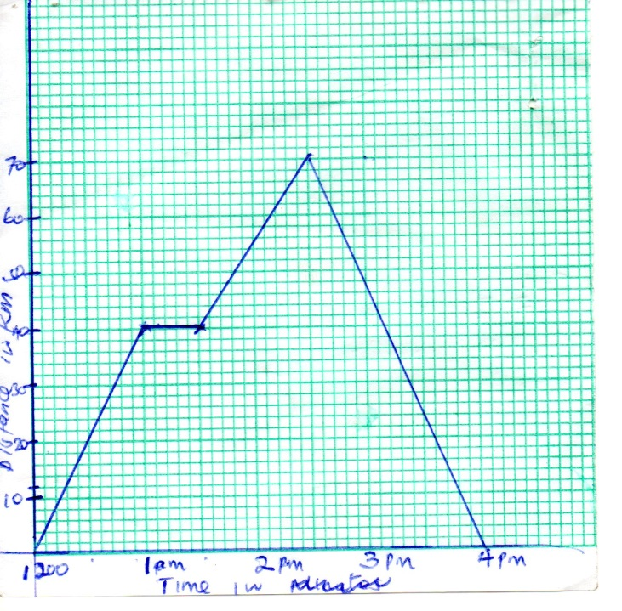

What is the average speed between 2.30 and 4pm

1. 50 km/h B. 46 2/3 km/h

C. 45 km/h D. 40 km/h

1. What is 5.517 x 14.5. correct to 2 decimal
2. 80.00
3. 80
4. 79.99
5. 79.10
6. What is the value of y in the equation

5x +3(x-4) = 36

1. 3 B. 5

C. 6 D. 8

1. Work out

815/16 – 55/8 – 13/16

1. 21/4  B. 21/8

C. 21/16  D. 1/32

1. A ranching company bought 250 goats at ksh.2000 each Later on 40 goats died and the company sold the remaining at 2200 each. What was the percentage loss
2. 38% B. 8%

C. 7.6% D. 7.5%

1. Which of the following is true
2. 2/3 = 0.66 B. 2/3 > 0.66

C. 2/3 < 0.66 D. 2/3 > 0.67

1. Which one of the following is not true about a rhombus
2. All sides are equal
3. All angles are equal
4. The diagonals bisect
5. Opposite sides are paralle
6. The figure below has perimeter 1120m

(6x30)m

(5x-20)m

What is the area in ares

1. 75900
2. 759
3. 75.9
4. 75900
5. Which of the following numbers is two million thirty five thousand and eight hundredths.
6. 2035800
7. 2035000.08
8. 235000.08
9. 235000.008
10. The structure is made with square blocks 1cm by 1cm by 1cm.

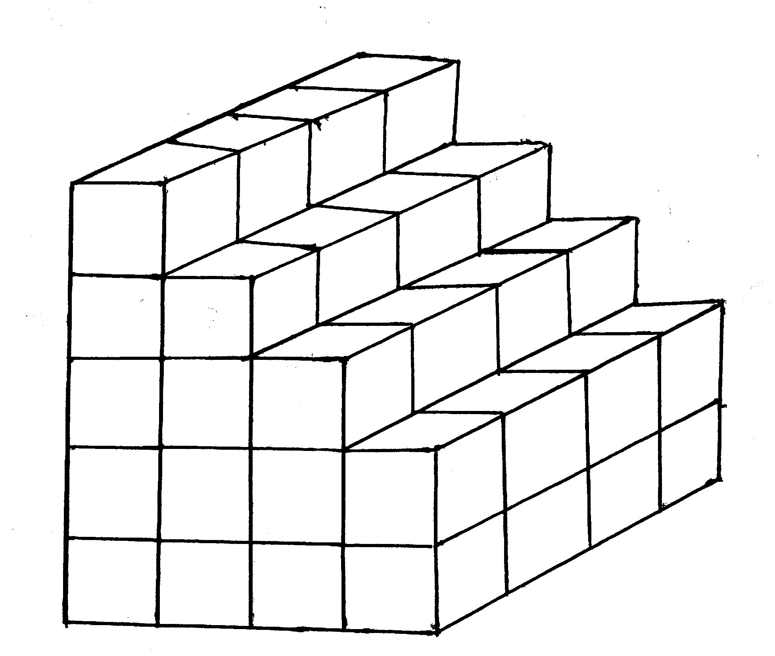

How many blocks are needed to complete the structure.

1. 144 B. 84

C. 64 D. 60