**COMPETENCE BASED ASSESMENT**

**GRADE 2 YEAR 2020**

**(MONITORING LEARNERS PROGRESS)**

**MATHEMATICS ACTIVITIES TIME:**

NAME:

1. **Count and write the number**.

                               

1. 25 is ____ hundreds ___ tens and ___ones.
2. 100 is ____hundred ____tens and ___ ones.

**Write the numbers in words**

1. 9 _____________________________
2. 15 ____________________________

**Fill in the missing number**

1. 24, 26, 28, 30, ______ 34
2. 85, 80, 75, 70, ______ 60
3. Which one is a quarter

|  |  |
| --- | --- |
|  |  |
|  |  |

**B**

**A**

1. 70 – 50 =
2. 19 - = 12

1. Daniel planted 19 lemon trees last week. He planted 24 lemon trees this week. How many trees has Daniel planted altogether
2. 28

+ 29

|  |
| --- |
|  |

1. 37

+ 6

|  |
| --- |
|  |

1. 4 + 6 + 5 =
2. Which one holds more



**B**

**A**

1. Draw an oval shape
2. 5 × 7 =
3. 10 × 4 =
4. Ben has 5 pencils. He gave peter 2 pencils. How many pencils was Ben left with?
5. 22 – 5 =
6. Draw a rectangle
7. September has how many days _____________
8. 15 + = 20

1. 8 ÷ 4 =
2. Ruth shared 15 bananas equally among 3 children. How many bananas did each child get
3. Which one is heavier?

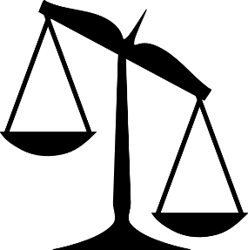

**B**

**A**

sugar

**stone**

___________________________

1. What is the time?

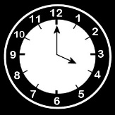_______________________

1. Complete the pattern

1. 20 ÷ 4 =
2. There are _____________ in a year.
3. **0** hundreds **9** tens and **7** ones is _______
4. **4** hundreds **2** tens and **5** ones is _______
5. Hellen bought a school bag at Sh. 70. Joash bought the same type of bag at sh. 90. How much money did Hellen save?

__________________________________