MONITORING LEARNER'S PROGRESS
001
GRADE 4 - 2020

ART AND CRAFT, HOME SCIENCE &MUSIC
Name
School name
The teacher to fill the grid below after marking the learner's work.
Assessment rubric
SUBJECT | Exceeds  Expectations  (25) |  | Meets  Expectations (13 - 24) | Approaches  Expectations (8 12) | Below  Expectations
ART AND CRAFT
MUSIC
HOME SCIENCE

ART AND CRAFT
- How do we correct a wrong drawing?
(draw, rub, smudge)

- What materials do we use for drawing?
- ________________________
- ________________________
- ________________________
- ________________________
- Use a crayons to colour the following
(a) (b)

- The technique of creating softer, blurrier shadows in art is called___________________
(drawing, gradation, smudging)

- Draw and colour a cup using a red colour.

- _________ is the lightness or darkness of a colour
- ____________ is the technique of picture making that involves cutting and pasting different pictures together to make one pictorial composition.
(collage, montage, photography)

HOME SCIENCE
- Name these pictures

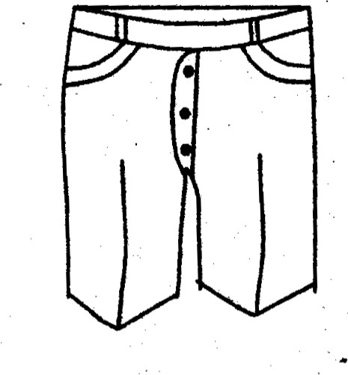
______________________

b)

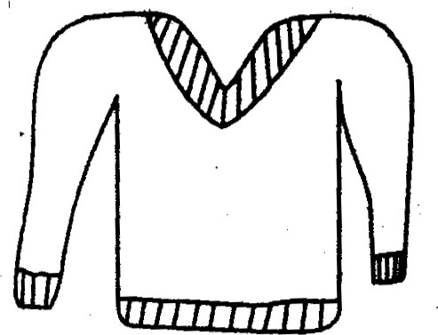
________________________
- What do we use at home to?
- Cut the grass?
_______________
- Clean the toilet?
_________________
- Remove dirt?
______________
- Write down five things found in a kitchen
- _________________
- _________________
- _________________
- _________________
- _________________
- Draw and name 5 utensils used at home
a)

_________________
b)

___________
c)

_____________
d)

___________
e)

___________
- Identify any two common diseases in our community
a) _________________
b) ________________
6. Identify any two food groups
a) _______________
b) _______________
MUSIC
- Write down any five words found in the national anthem
- _______________
- _______________
- _______________
- _______________
- _______________

- Identify any three types of songs
- _____________
- _____________
- _____________

- Name the following instrument
