**SOCIAL STUDIES STD 7 - 2020 Time: 2hrs 15mins**

**UPENDO AREA**

N



P

1. What is the direction of game reserve from the tea plantation?
2. South East B. North West

C. South West D. North East

1. The type of climate to the western part of the area is likely to be?
2. Cool and wet
3. Hot and wet
4. Cool and dry
5. Hot and dry
6. The person incharge of Elewana Sub county is
7. Governor
8. County Commissioner
9. Deputy County Commissioner
10. Member of County Assembly
11. Which one of the following economic activity is LEAST practiced in Upendo area?
12. Mining
13. Crop farming
14. Lumbering
15. tourism
16. Shauriako market has grown and expended due to
17. security
18. tea growing
19. educational facilities
20. trading activities
21. The point marked P is called?
22. junction B. tributary

C. Delta D. Confluence

1. The length of the tarmac road is approximately
2. 9 KM
3. 10 KM
4. 5 KM
5. 7 KM
6. Kenyas leading crop export is
7. Soda ash
8. Tea
9. Coffee
10. Sugarcane
11. The type of rainfall experienced within the coastal region and lake region parts of Africa is
12. Relief
13. Convectional
14. Cyclonic
15. Orographic

**Use the map of Africa to answer question 10 and 11**

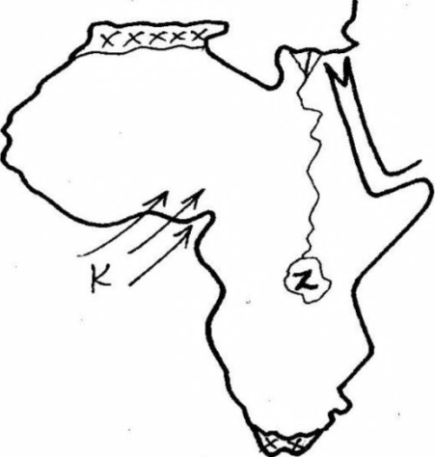

Y

W

1. The current label Y that influences climate in Africa is called ________
2. Canary cold current
3. Benguela cold current
4. Somali warm current
5. Mozambique warm current
6. The wind marked W is known to as___________
7. Western winds
8. South east trade winds
9. Harmmatan winds
10. North winds trade winds
11. The sun is overhead on tropic of cancer on
12. 22nd December
13. 3rd march
14. 21st June
15. 23rd September
16. Which one of the following is not a member of a clan?
17. Grandfather
18. Sister
19. Father
20. grandmother
21. The method of fishing drawn below is called___________

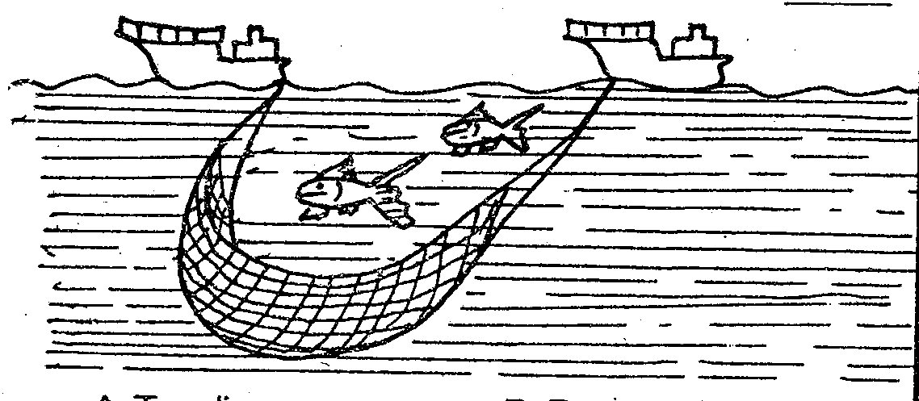

1. Purse seining
2. Trawling
3. Drifting
4. Long lining
5. Which community resisted against European in Kenya
6. Abawanga
7. Maasai
8. Giriama
9. Agikuyu
10. The main tourist attraction along the coastal region is
11. Wildlife
12. Historical sites
13. Culture
14. Sandy beaches
15. Which one of the following is not a member Country of southern African development community (SADC)
16. South Africa
17. Angola
18. Namibia
19. Ghana
20. Africa is separated from Sinai peninsula by the
21. Red sea
22. Cape guardafai
23. Suez canal
24. Strait of babel
25. Nyamwezi was headed by chief called
26. Rugaruga
27. Ntemi
28. Arkoyot
29. Oloibon
30. Who among the early visitors was **not** a trader?
31. Morton Stanley
32. William Macknon
33. Carl Peters
34. Seyyid Said
35. The following is a description of a multipurpose river project in Africa
36. Has source of water from three rivers
37. Initiated by the first president of its country
38. Hydroelectricity mainly used for smelting minerals
39. Water used for irrigation of crops sugarcane, tobacco, peas

The river described is called

1. Volta River Scheme
2. Aswan High Dam
3. Perkera Irrigation Scheme
4. Kariba Dam
5. Pastoral farming has benefited the economy of Africa in the following ways except one, which one?
6. Reclaimed land that is not agriculturally viable
7. Large number of animals are slaughtered for meat export
8. Poor quality livestock is destroyed and replaced with exotic breeds
9. Livestock products are used in manufacturing industries
10. If Kenya wanted to import hardwood timber which of the following countries within COMESA can supply to Kenya?
11. Sudan
12. Egypt
13. Namibia
14. DRC Congo
15. The main function of economic community of west African elders modeling group(ECOMOG) is?
16. Produce common currency for regional trade
17. Develop transport within member state
18. Select suitable member states within the region
19. Ensure political stability within state members
20. The following countries in Africa are linked by the Trans African Highway except?
21. Uganda
22. Ghana
23. DRC congo
24. Cameroon
25. The problems facing urban areas in East Africa can be best solved by?
26. Decentralization of industries to create jobs in the rural areas
27. Demolish slums and develop decent houses in urban areas
28. Arrest all suspected criminals in urban areas
29. Recycle all the garbage to ensure clean environment
30. The following are contributions of a prominent leader in Africa
31. He was among the founder member of OAU
32. He was awarded the beyond war award in 1985
33. He belrused in sharing resourses as opposed to private ownership
34. He improved formal education in his country

The leader described above is?

1. Julius nyerere
2. Kwame nkurume
3. Haile Selassie
4. Nelson mandela
5. Which of the following vegetation zones mostly covers large parts of the Bahr-el Ghazal region in southern sudan
6. Semi desert vegetation
7. Savanna woodland
8. Papyrus swampy vegetation
9. Mountain vegetation

**Amharas**

**Arabs**

**Y**

**Tigreans**

1. Which of the following Semitic group represents Y
2. Sanye
3. Dahalo
4. Falasha
5. Burungu
6. The following are problems facing fishing in Africa, which one is not
7. Presence of water hyacinth
8. Water pollution from leaking water vessels
9. Lack of sufficient funds to buy fishing equipment
10. Improved infrastructure
11. Lake formed behind Aswan High Dam is called?
12. L. Masinga
13. L. Tana
14. L. Kariba
15. L. Nasser
16. The **main** reason of establishing Perkerra irrigation scheme is to
17. Increase food production
18. Make use of available water in rivers
19. Settle landless people
20. Make use of desert areas
21. The following represents plain Nilotes in Uganda except
22. Samburu
23. Jie
24. Iteso
25. karamajong
26. The common form of communication in Africa is
27. Mobile phones
28. Radio
29. Social media
30. Fax mile
31. The **main** problem that faces wildlife in Kenya is
32. Terrorism
33. Insecurity
34. Poaching
35. Drought
36. Which one of the following is **NOT** example of Mande speakers?
37. Malinke
38. Dagomba
39. Soninke
40. Susu
41. Who writes minutes during the staff meeting?
42. Head teacher
43. Senior teacher
44. Secretary to BOM
45. Deputy head teacher

**Use the diagram to answer question 38**

X

1. The vegetation labeled x is referred to as
2. Bamboo
3. Rain forest
4. Snow and bare rock
5. Health and moreland
6. I am a mineral found in Africa. I am used to make electrical wires, telephone wires, coins and vehicle radiators.

Whom am I?

1. Gold
2. Copper
3. Diamond
4. Soda ash
5. The method used in solving conflict where the third person comes in to intervene is called?
6. Litigation
7. Reconciliation
8. Dialoque
9. Mediation
10. The method of mining fluorspar is called_____________
11. Dredging
12. Shaft method
13. Open cast
14. drilling
15. The instrument used to measure humidity is
16. Barometer
17. Rain gauge
18. Hygrometer
19. Thermometer

**Use the diagram to answer question 43 to 45**

z

M

1. The above feature shows formation of
2. Rift valley
3. Block mountain
4. Volcanic mountain
5. Lava dammed lake
6. The force marked M are known as
7. Tensional forces
8. Down thrust forces
9. Compressional force
10. Upthrust forces
11. Which one of the following features was Not formed as a result of the above process?
12. Danakel Alps
13. Ruwenzori
14. Mau Ranges
15. Cape ranges
16. Which one of the following countries was **NOT** a French colony?
17. Benin
18. Chad
19. Lesotho
20. Seychelles
21. Which one is **NOT** a way of inclusion of people with special needs in the society
22. Name calling them
23. Having positive attitudes
24. Create friendly environment
25. Giving equal opportunities
26. The process where citizens vote for a proposed constitution is known as
27. General election
28. Referendum
29. Census
30. voting
31. Which one of the following has greatly contributed to the lack of peace in Kenyan Somalia border
32. disagreement about boundaries
33. cattle rusting
34. lack of an effective government in Somalia
35. lack of employment of Al-Shabaab
36. Kenya became a Republic on
37. 1st June 1963
38. 20th oct 1952
39. 12th Dec 1964
40. 1st June 1964
41. Who among the following persons in NOT a member of the cabinet?
42. President
43. Chief Justice
44. Attorney general
45. Cabinet secretaries
46. Who among the following chairs parliamentary sessions
47. Speaker
48. Chief justice
49. President
50. governor
51. The head and chairperson of the County executive committee is?
52. Governor
53. Senator
54. MCA
55. President
56. The chief administrator and accounting officer of the judiciary is the
57. Judges
58. Chief justice
59. Chief Registrar
60. Attorney general
61. The following are some of the causes of lawlessness in the society. Which one is **NOT**?
62. Education
63. Poverty
64. Tribalism
65. corruption
66. Okumosi came across a Std seven girl who had been raped in the nearby sugarcane plantation. The immediate action that was supposed to be taken was?
67. Inform the head teacher
68. Inform the chief
69. Report to the nearest police station
70. Take her to the nearby hospital
71. The following are conditions required for growth of a certain crop in Africa
72. High temperature of 21°c - 27°c
73. High humidity
74. Dry season before harvesting
75. Fertile soils

The crop is likely to be

1. Tea
2. Sugarcane
3. Pyrethrum
4. sisal
5. Which of the following species of trees is a soft wood?
6. Camphor
7. Elgon teak
8. Eucalyptus
9. Meru oak
10. The highest mountain in Africa is
11. Mt. Kenya
12. Mt. Kilimanjaro
13. Cape Ranges Mountain
14. Mt. Ruwenzori
15. A situation where days and nights are almost equal is known as
16. Solstice
17. Hemisphere
18. Tropics
19. Equinox

**C.R.E**

1. Which one of the following is the MAIN reason why God put Adam and Eve in the Garden of Eden?
2. To eat all the fruits in the garden except fruits from the tree in the middle
3. To guard it and cultivate it.
4. To name all the animals
5. Because they were special creatures
6. During the call of Abraham, God instructed him to move from _______ to ______
7. Haran to Ur
8. Canaan to Haran
9. Haran to Canaan
10. Ur to Canaan
11. Jacob wrestled with an angel of the lord at a place called
12. Peniel
13. Bethel
14. Haran
15. Ur
16. Who among the following advised Moses to appoint judges to help him solve cases?
17. Samuel
18. Pharaoh
19. Aaron
20. Jethro
21. During the Exodus God led the Israelites in the form of
22. Fire and flaming torch
23. A smoking fire pot and cloud
24. Fire and cloud
25. Pillar of clouds and a rainbow
26. Which of the following was an achievement of the second King of Israel?
27. Bringing the ark of the covenant to Jerusalem
28. Building the temple
29. Taking Uriah’s wife
30. Marrying many wives
31. 1st Kings 3:9 “so give me the wisdom I need to rule your people with justice and to know the difference between good and evil” These words were spoken by
32. Saul
33. Solomon
34. David
35. Samuel
36. Who among the following prophets said that the Messiah would be wonderful counselor?
37. Micah
38. Joel
39. Hosea
40. Isaiah
41. I am a prophet; I anointed the first and second King of Israel. Who am I?
42. Isaiah
43. Micah
44. Jeremiah
45. Samuel
46. Who among the following were in the temple during the presentation of Baby Jesus?
47. John and Zachariah
48. Hannah and Elikanah
49. Annah and Simeon
50. Zachariah and Elizabeth
51. During the transfiguration of Jesus. Gods voice was heard saying
52. “Do not move any closer, you are standing on holy grounds”
53. “This is my own dear son that am well pleased with, listen to him”
54. “Never again shall a destroy the whole world using floods”
55. “This is my own dear son that am well pleased with”
56. How old was Jesus when he accompanied his parents to Jerusalem to celebrate the Passover festival?
57. Twelve years old
58. Eight years old
59. Forty days old
60. Eight days old
61. What virtue do Christians learn from the parable of the Pharisee and the tax collector?
62. Repentance
63. Humility
64. Thankfulness
65. Persistence
66. Which one of the following is not a teaching of Jesus on prayer?
67. Pray while fasting
68. Use many words to pray
69. Prayer should be said in humidity
70. Be persistent
71. What lesson do Christians learn from the incident when Jesus healed the ten leapers?
72. Always forgive
73. Be humble
74. Be thankful
75. Resist temptation
76. “Surely this man was the son of God”. Who said these words?
77. The Roman officer
78. Simeon of Cyrene
79. The adamant thief
80. The repentant thief
81. When did Cleophas and his friends who were on the way to Emmaus recognize Jesus?
82. When he said the lord’s prayer
83. When he greeted them
84. When he asked them what they were saying
85. When he broke the bread
86. What was Saul going to do in Damascus when light struck him?
87. Preach the gospel
88. Pray for Christians
89. Persecute Christians
90. To stone Stephen
91. The Ethiopian Eunuch baptized by Philip was reading the scripture from the book of
92. Jeremiah
93. Isaiah
94. Ezekiel
95. Daniel
96. Which one of the following books is an epistle written by Paul?
97. Romans
98. Hebrews
99. Jude
100. James
101. Which one of the following belief is found in both Traditional African community and Christianity
102. Resurrection of the body
103. Life after death
104. Holy trinity
105. Second coming of Christ
106. Which one of the following was carried out by priest in traditional African communities?
107. Solving disputes
108. Preaching
109. Making sacrifices
110. Baptizing believers
111. Which of the following is not a Christian practice?
112. Circumcision of male
113. Per taking Holy communion
114. Use of love portion
115. Burying the dead
116. In traditional African communities, youths were taught moral values by
117. Elders
118. Peers
119. Seers
120. warriors
121. Which one of the following is a way of caring for the environment?
122. Cultivating along river banks
123. Cutting trees for timber
124. Rearing a lot of livestock
125. Reclaiming riparian land
126. While playing in the school field, John picks a wallet with a thousand shillings note in it. As a Christian, what should John do?
127. Start looking for the owner
128. Keep it and take it to his mother
129. Throw the wallet and share the money with his friends
130. Take it to the teacher on duty
131. A standard seven girl is in relationship with a fellow standard seven boy. As a Christian, what advice will you give?
132. Their body is the temple of God and should stop the relationship.
133. Do it secretly so that other pupils should not know.
134. Marry one another and stop learning
135. Continue with the relationship but work hard in class.
136. Jane does not like doing her homework. What advice can you give as a Christian?
137. Help her with your book for her to copy
138. Pretend to the teacher that the book is lost
139. Stop being lazy and do her work
140. Tell her friend to be doing it for her
141. Christians **mainly** discourage abortion because
142. The foetus is innocent
143. Life begins at conception
144. It can lead to death of the mother
145. Abortion is a crime
146. The **main** reason why Christians condemn prostitution is because: it leads to
147. Misuse of sex
148. Spread of diseases
149. Unwanted pregnancy
150. Break up of families