SOCIAL STUDIES SUMMARY STANDARD 5
- PHYSICAL ENVIRONMENT
Dfn; Map is a drawing which represents the earth or parts of the earth on a flat surface
The surfaces are; 1. Sheet of paper
2. Chalk board
3. Wall
ELEMENTS OF THE MAP AND OTHER USES
- Title- this is the heading or name given to a map and it is written at the top or bottom of the map
- Frame-this is the border that is drawn around a map
- Key- this is the list of the symbols
- Scale- this is the relationship between the distances on the map and real distances on the ground
- Compass –it help to allocate the direction of a place on the map
The first compass direction is that of the nearest cardinal points
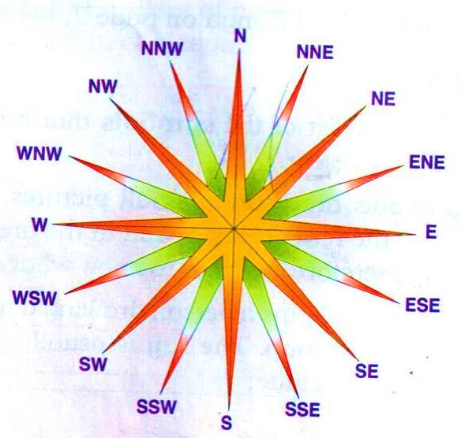
POSITION OF KENYA IN RELATION TO HER NEIGHBOUR
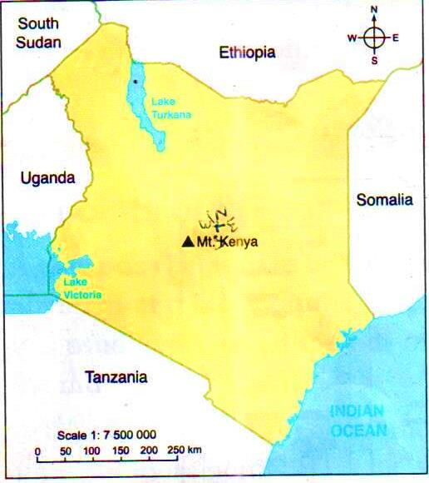
  - Kenya lies to the east of Uganda
  - It lies to the south of Ethiopia
  - Kenya lies to the north and north east of Tanzania
  - It lies to the north –west of the Indian Ocean
  - Kenya lies to the south east of Sudan
  - It lies to the west of Somalia

Size and shape of Kenya
- Kenya covers an area of 582646 sq. km.
- It is about, 800km from east to west and about 1000km from north to south

Main physical features
- Location of main physical features
- Physical features- are the natural things that are found on the surfaces of the earth examples swamps, lakes, ocean, plains, rivers, mountains, plateaus and valleys
- These features are categorized into two
    - Relief feature
    - Drainage features
- Reliefs –refers to the rise and fall of the land, includes mountains, hills, valleys, plains, highlands and lowlands
- Drainage- refers to all features that are related to water and its movement; they include basins, swamps, rivers, dams, lakes and oceans
LOCATION OF MAIN PHYSICAL FEATURES
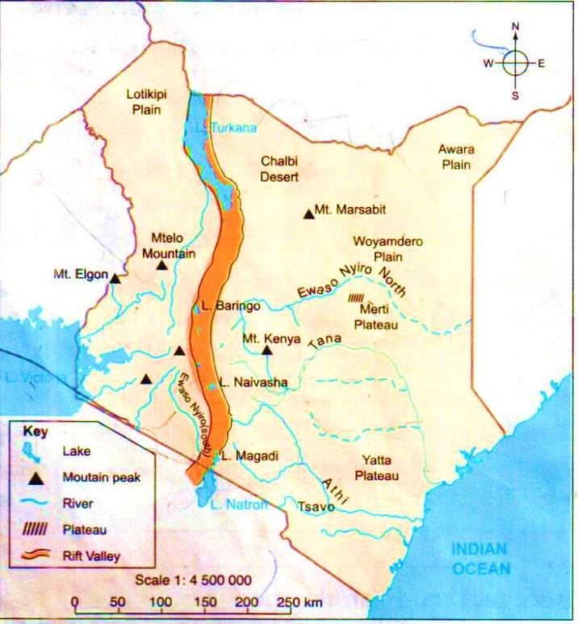
- Mountains –it is masses of very high land. Mount Kenya is the highest mountain in Kenya with the height of 5199m above sea level with the highest point being point Batian followed by point Nelion.
- Hills –are raised part of the land that are smaller than mounts; they are many hills in Kenya.
- The riftvalley- is a big depression with steep sides. It is formed by faulting and sinking .The wall of the Rift Valley is called Escarpment.
- Plateaus- Is a wide raised ground with a surface that is almost flat. The biggest plateau is called Nyika Plateau in Kenya.
- Plains- are large areas of land that have a surface that is really flat or level e.g. Athi –Kapiti. Plains which are located just outside Nairobi city.
- Escarpments- are very steep slopes of the Rift Valley.
DRAINAGE FEATURES
Rivers
- It is a large natural stream of water that flows in definite channels across the land.
- Permanent rivers-these are rivers that flow throughout the year.
- Seasonal rivers-these are rivers that dry up during the dry season.
- Where the river start is called the source and where it ends is called the mouth.
- R. Tana is the longest river in Kenya and its source is Mt. Kenya and it mouth is Indian Ocean.
- River Nyanda and its source is Nandi hill and mouth is L. Victoria
- River Athi start from Ngong Hills and enters the Indian Ocean as River Sabaki.
- River Ewaso Nyiro North its source is in the Aberdare Range and it mouth is the Lorian swamp.
- R.Turkwell has its source is in Mt. Elgon and its mouth in L. Turkana.
- R. Nzoia has it source in Mt. Elgon and its mouth in L. Victoria.
PHYSICAL FEATURES |  | EXAMPLES | REGION WHERE FOUND
Plateaus |  | Nyika ,Yatta | Coast
 |  | Rosarus, Merti , Yatta ,Sagarema, Kaisut ,Nyika | Eastern
 |  | Lerochi ,Laikipia | Rift Valley
 |  | Laikipia | Central
Palins |  | Coastal Plain | Coast
 |  | Mwea ,Naro ,Moru .Ndeiya | Central
 |  | Korante ,Kapiti .Ngaso ,Sigiso | Eastern
 |  | Embakasi ,Athi ,Kapiti | Nairobi
 |  | Lotikipi ,Loita ,Siana ,Elbarta ,Siana ,Iponye Suk ,Lebatian | Rift Valley
 |  | Kano Plains | Nyanza
 |  | Bilesha ,Woyamdero ,Wachadma , Bokhoi , Sardindida , Adabli ,Awara ,Boji ,Ghujani | North Eastern
Valleys and escarpment |  | Nguruma, Mau, Nandi ,Keiyo ,Kerio | Rift Valley
 |  | Nandi | Western
Mountains and ranges |  | Mount Kenya,Aberdare Ranges ,Lesatima
 |  | Marsabit ,Kulal ,Mount Kenya | Central
 |  | Longonot, Ndoto Mountains ,Songot Mountains ,Ol-Doinyo Nyiro ,Mtelo ,Mau ,Londiani Mountains ,Loriu Range | Eastern
 |  | Lali; Mwembe Tangu ,Shimba ,Ndzimbo ,Taita | Rift Valley
Hills |  | Lali, Mwembe Tangu ,Shimba,Ndzimbo,Taita | Coast
 |  | Tumutumu ,Kinangop , Nyeri | Central
 |  | Chyulu, Mbooni ,Mua ,Kwamathumba, Kiang’ombe ,Nyambene , Bura ,Galadi, Tetesa Ituri ,Sigiso ,Huri | Eastern
 |  | Loima ,Ngapoi, Luturere, Karasuk, Samburu ,Cherengani, Tugen, Meto, Loita, Eldoinyo, Narok | Rift Valley
 |  | Homa, Rabuori, Kiabonyoru, Masono, Gembe ,Gwasi ,Ruri | Nyanza
 |  | Galla, Aus Madali, Burwen,Korondi Hills,Ajao Hills, Buite ,Danissa, Golberobe, Bamba ,Raiya ,Gringo ,Madokhori ,Gurar | North Eastern
DRAINAGE FEATURES
Ocean and lakes | Indian Oceans ,Lake Jipe ,Lake Chal |  | Coast
 | L. Ol Bolossai ,Sasumua And Ndakaine |  | Central
 | L.Paradise, L. Nkunga ,Masinga ,Kindaruma ,Kiambere ,Kamburu |  | Eastern
 | L. Amboseli ,L.Magandi ,L. Naivasha ,L. Elementaita ,L. Nakuru, L. Bogoria ,L. Baringo ,L. Logipi ,L. Turkana |  | Rift Valley
Rivers | Rare, Sabaki, Tana, Galole, Ramisi,Tsavo,Bura ,Kolani, Tula |  | Coast
 | Ruiru, Thirika, Thiba, Mathioya, Malewa, Nyamidi, Sagana,Chania,Gura |  | Central
 | Milgis,Athi ,Tiva ,tana,ewaso nyiro ,north ,balal, lagh choichuff |  | Eastern
 | Mkoyeti, ngong, Nairobi,gatharaini |  | Nairobi
 | Ewaso nyiro south, mara, napas, malewa,perkerra,suguta, kerio ,turkwel |  | Rift valley
 | Malakisi ,sio ,nzoia, yala ,khalaba, kuywa,lwakhakha,lusumu |  | Western
 | Kuja, migori, mogusi ,sondu, gucha,miriu, nyando, awach,Yala ,Nzoia ,Ongoche |  | Nyanza
 | Lagh ,dera, bor, sure, dima, katulo, dodori |  | North eastern
Swamps | Lotikipi,saiwa ,kingwai |  | Rift valley
 | Kano |  | Nyanza

Swamps
- Are wet places covered with water and some vegetation.
- They are also called mashes (poorly drained because it contain clay soils)
- The main plants that grow in swamps are reeds such as papyrus and grass.
- Exmaples of swamps e.g. Lorian Swamps ,Ewaso Nyiro ,Yala Swamps –Yala
Oceans
- It is a mass of salty water that covers a large area.
- Indian Ocean is only ocean found near Kenya .The Indian Ocean boarders the coast region of Kenya.
Lakes
- It is a body of water that is surrounded by land.
- Examples of lakes in Rift Valley are Naivasha ,Bogoria ,Baringo ,Nakuru ,Elementaita ,Turkana (L. Natron in Tanzania)
Relief regions of Kenya
- Relief region –is a large area with generally similar characteristics because of the physical features found there.
Types of relief region in Kenya
- The coastal plains
- The highlands
- The lake victoria basin
- The plateau
- The rift valley
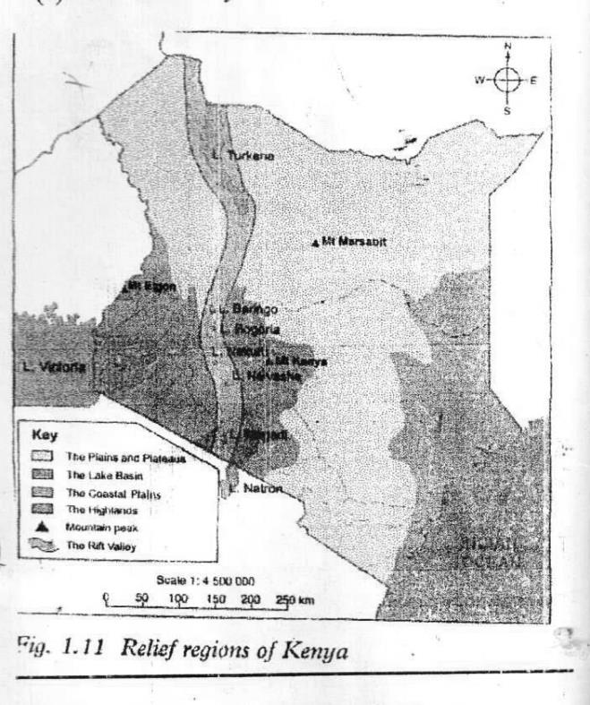
Characteristics of relief region in Kenya
The Coastal Plains
- Plains is a low lying surface that is almost flat. It covers parts of Coast and the North Eastern region of Kenya.
Influence of physical features on human activities
- Mountain help in formation of rainfall e.g. relief rainfall where farming is done.
- Cool and wet climate is experienced in the highland where dairy farming is done and growing of coffee and tea.
- High rainfall is experienced in the highland.
- Mountain encourage recreational activities e.g. mountain climbing and domestic and foreign tourist visit.
- Presence of mountains discourages construction of railway.
Plateau
- It’s good for pastoralism.
- It is suitable for wildlife.
- Easy construction of railway.
Rift Valley
- It has beautiful sites, diverse wildlife and attractive scenery that encourage tourism.
- Encourage livestock and crop farming.
- Steep sides of R. Valley not suitable for settlement or for farming.
- Difficult in construction of roads and railway on the escarpment.
Rivers and Lakes
- It encourages settlements because sources water for domestic use and irrigation.
- Encourage fishing and farming e.g. L.Victoria ,R.Tana
- Used as a mean of transport e.g. L.Victoria ,R.Tana
- River that cause flooding discourage settlement e.g. R. Nzoia which floods at the Budalangi plains displace people.
Swamps
- It discourages human settlement because they are breeding ground for Bilharzia worms and mosquitos which cause diseases.
- They make roads and railways construction difficult because of stagnant water.
CLIMATE
- Weather –It is the condition of the atmosphere of a place at a particular time.
- Climate –It is an average weather condition observed for a long period of time e.g. over 30 years.
- Weather can be described as rainy, sunny, cloudy, windy at place at a given time.
- Climate can be described as wet, dry, hot, cold, warm or cool.

The climate regions of Kenya
COASTAL REGIONS
Characteristics
- It boarder Indian Ocean.
- It is about 200 metres above sea level.
- It is narrow at the Kenya-Tanzania boarder and wide around R. Tana
- There are small hills within the plain e.g. Shimba hills in Kwale District.
The plateaus
- It is a wide raised ground with a surface that is almost flat.
- Nyika plateau is the biggest plateau in eastern African and Kenya.
Characteristic
- Surface is generally flat.
- It lies between 250-1100 metres above sea level.
- It is lower in the East but rises gradually to the west .Some hills are found here e.g. Taita and Iluri hills.
- There are resistance hill called Inselbergs.
- Some mountains are found here e.g. Nyiro Ndoto, Kulal ,Marsabit .
- The areas are covered with grass and thorny bushes.
The Highland
- It is an area with many mountains and high hills.
Characteristics
- It lies between 1500-5199 metre above sea level.
- The area is divided by Rift Valley
- Mt. Kenya is the highest point of highlands with 5199 metres to the east and to the west is Mt. Elgon with 4321 metres above sea level.
- Highland is a source of rivers e.g. Yala ,Nzoia ,Sondu ,Miriu ,Kuja and Nyando which flow into L. Victoria
The Rift Valley
Characteristics
- It is very low e.g. Lokitipi plain near L.Turkana .
- It have mountains e.g. Suswa, Mt. Longonot.
- It bordered by steep sides called escarpments on both sides.
- Several lakes are found in Rift valley e.g. Naivasha ,Baringo ,Bogoria ,Nakuru e.t.c.

The Lake Victoria Basin
- It is around L. Victoria
Characteristics
- It lies between 1000-2000 metres above sea level.
- Some are experience floods e.g. Kano Plains, River Sondu, R. Nyando passes Kano plain causes floods.
- It has some plateau e.g. Nyabondo plateau.
- It have hill e.g. Gwasi ,Homa
- The height of the land increases as one move away from the lakes.
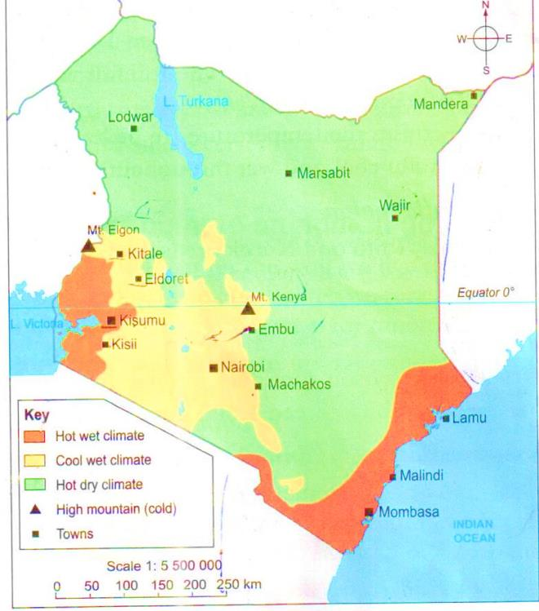

Types of climate regions of Kenya
- The hot and wet climate region (modified equatorial climatic region)
- Cool and wet climatic region (modified tropical climate)
- The tropical climatic region
- The hot and dry climatic region (desert and semi-desert climatic region)
- The mountain climatic region
Characteristics
The modified equatorial climatic region
- NB- Found in the coastal and L. Victoria region e.g. Mombasa, Malindi and Kisumu
- Temperature are high over 25⁰c.
- Daily range of temperatures is low.
- Receive convectional region.
- Rainfall is high between 1000mm to 15000mm per year.
- Experience long rain in March and June and short rain in Octo ber and December.
- Climate is affected by wind blowing from the ocean at the Coast.
- Rainfall distribute well throughout the year.
- The region is hot and wet throughout the year.
- The Modified Tropical Climatic Region
- N.B. –found in the Kenyan highland e.g. Kisii, Kitale, Kericho and Nairobi.
Characteristics
- Receive relief rainfall
- Temperature ranges between 180c and 25oc.
- Rainfall varies between 1100mm-2400mm per year.
- High altitude causes the temperatures to be lower.
- Cool and wet throughout the year.
The Tropical Climatic Region
NB- Found in Kwale ,Taita and Narok areas.
- High temperature
- One rainy season
- Dry season sometime continue for over 5 months.
- Rainfall does not exceed 1000mm per year.
The Semi-Desert and Desert Climatic Region
- NB- Found in Northern, North Eastern and some part of Eastern Kenya e.g. Chalbi desert in Marsabit.
- High temperature during the day and low during the night.
- High temperature throughout the year between (25⁰C-30⁰C).
- Low rainfall
- Hot and dry throughout the year.
- Most of months are dry causing droughts.
The Mountain Climatic Region
- NB.-Found in Mt. Kenya and Mt. Elgon
- Rainfall is high ranges between 1100mm and 2300mm per year.
- Temperatures are low ranging from 0⁰C-15⁰C
- Experience cold and wet at the top of mount.
- It is characterized by two sides, the leeward sides and windward side.
- The leeward side is also known as rain shadow.
- The windward side receives relief rainfall while the leeward side is drier.
The influence of climate on human activities
- The hot and wet climate
- Is good for farming Crops grown e.g. sugarcane, banana, coffee, sisal , cashew nut, coconuts
- The cool and wet climate
- It is good for farming activities e.g. maize, coffee and tea and dairy farming and forest growing.
- The dry and hot climate
- It discourages farming, the main activities carried out are pastoralism, they search water and pasture.
- The movements of pastoralist and their animals in search of water and pasture is called Nomadic-pastoralist.
SOIL
- Soil is the layer of material on earth surface on which plants grow.
Major soil types in Kenya
- Alluvial soils
- Volcanic soils
- Black cotton soils (clay)
- Loamy soil
- Sandy soil
Alluvial soil
- Another name is young soils. They are formed after deposition of eroded material e.g. river valleys, flood plains e.t.c.
Volcanic
- It is red in colour.
- Found in highland and some part of Rift valley.
- Are very fertile.
- It is deep and well-drained soil.
- Suitable for growing coffee and tea.
Black cotton soil
- Also called clay soil.
- Have very small particles.
- They crack when dry.
- When it rain it become sticky and heavy .
- They do not loose water easily.
- Found in Transmara ,Narok ,Kajiado ,Kapiti ,Kano ,Mwea and Samburu areas.
Sandy Soil
- Found in arid and semi-arid areas e.g. Northern Kenya and parts of the coastal region and some river valleys.
- They have large stone particles.
- It loses water very fast.
- They are not fertile.
Loamy soil
- Mixture of clay and sand.
- They are fertile.
- Found in Nyanza, Western and Rift valley Region.
Uses of soil
- It is used to grow food and cash crops.
- It is used as building material.
- The growth of grass and other vegetation is supported by soil.
- Used in pottery industry to make pots, jars and vases.
- Used for decoration during traditional ceremonies, festivals and cultural events.
- Soil is used for religious reasons.
- During ceremonies like circumcision, young people smear mud on their bodies.
SOIL EROSION
- It is the process by which the top soil is carried away by either water or wind.
Causes of soil erosion
- Cutting down of trees leaving the land bare.
- Cutting down of trees without placing is called deforestation.
- Cutting down of trees and replacing them is called re-afforestation.
- Planting trees where there is no existing is called reafforestation.
- Planting of trees and crops together is called Agro- forestry.
- Overstocking and overgrazing –this is keeping many animals that you cannot support them.
- Monocropping –this is growing of one type of crop only over a long period of time.
- Improper cultivation practices- wrong cultivation practices e.g. ploughing up and down a slope increase chances of soil erosion because water easily runs down the furrows.
- Ploughing done along the contours.
Types of oil erosion
- Splash erosion –controlled by mulching
- Rill erosion – controlled by terracing
- Sheet erosion –controlled by cover crop
- Gulley erosion –controlled by building gabions, check dams
VEGETATION
- Refers to grass, bushes, trees and other plants which grow naturally in an area as well as those planted by people.
Types of vegetation in Kenya
- Forests
- Savannah woodlands
- Savannah grassland
- Scrub
- Semi desert and desert
- Swamp vegetation
- Mangrove forests
- Mountain vegetation
FOREST
- This is a large area with many trees growing close together. The trees form a continuous layer at the top (umbrella like) called canopy)

Types of Forest
- Natural Forest –It grows without any support of human being, the trees found there in Meru- Oak, Podo ,Mvule and Elgon teak ,camphor mahogany.
- Planted Forest – it grow with the support of human being, the trees that grows are pine, cypress and eucalyptus.
- Mangrove forests is also called Marshy
- Mangrove swamps are found near the coast region.
Importance of Vegetation
- Help to reduce soil erosion
- Help to modify climate and act as water catchment area.
- Area with vegetation is good for grazing.
- Some plant is used in production of herbal medicine.
- They are home for wild animals.
- It act as a source of raw material e.g. Timber, Papers, Furniture industries.
- Timber from trees is used for building houses while grass is used to thatch the roof of traditional houses.
- Trees are a source of firewood
PEOPLE AND POPULATION
Language groups in Kenya
- There are 42 local languages spoken in Kenya.
- Communities which speak in languages that share some similar words form a language group.
- The language groups in Kenya include the:
- Bantu
- Nilotes
- Cushites
- Asians
- Europeans
THE BANTUS
- The original homeland of the Bantu was the Congo Forest in the Democratic Republic of Congo (D.R.C.)
- The Bantus are mainly cultivators of crops.
- There are divided into two groups;
- Western Bantu
- Eastern Bantus(coastal and central bantu)
Western Bantu are:-
- Abaluhya
- Abagusii
- Abakuria
Eastern Bantus
Central Bantus
- Agikuyu , Aembu ,Ameru , Akamba ,Ambeere
Costal Bantus
- Pokomo ,Wadawida (Taita) ,Wataveta ,Mijikenda ,Waswahili
The Nilotes (the Pastrolism)
- Its original homeland is Southern Sudan.
- Nilotes practiced pastoralism and grew crops such as millet and sorghum.
- There are three groups of Nilotes ;
- The River- Lake Nilotes –Luo
- The Plain Nilotes
- The Highlands Nilotes
The River-Lake Nilotes (Fishermen)
- The Luo lived along rivers and lakes.
- The ancestors originate in Bahr-el-Ghazal in Southern Sudan.
- They practice fishing.
The Highlands Nilotes (Farmers)
- It is also known as Kalenjin .
- They consit of Kipsigis , Sabaot ,Nandi ,Pokot ,Marakwet ,Keiyo ,Tugen
The Plain Nilotes (Pastrolism)
- They include Njemps (Hichamus) ,Samburu ,Maasai ,Iteso and Turkana.
- They settled on the plains where Pastrolism is practiced.
THE CUSHITES
- They originate in Southern Ethiopia.
- They keep cattle, sheep and goat and grow millet and sorghum.
- They are divided into two groups;
- Southern Cushites
- Eastern Cushites
- Eastern Cushites
- Somali, Borana ,Galla Or Oromo ,Gabbra, Rendille ,Burji.
- Southern Cushites
- Sanye/Bahalo
THE SEMITES
- They include Arabs and Jews.
- They originated from Arabia.
- Arabs are the main Semitic community in Kenya.
- They settle along the coast.
- They are mainly traders.
THE ASIANS
- Originate from Asia.
- They first come to Kenya as a railway construction along Kenya-Uganda railway construction.
- They are brought by British to provide cheap labour that was needed to construct the railway from Mombasa to Kisumu which completed in 1901.
- Examples of Asians are:
- Indians, Pakistans, Japanese and Chinese.
THE EUROPEANS
- They originated from Britain, Germany, France and Italy.
- They are mainly business people and other practice farming in the country sides.
POPULATION
Population- this refers to the total number of people living in a particular area.
Densely populated area- area with many people.
Sparsely populated area- area with few people.
Population distribution –This refers to the way people spread over an area.
Factors influencing population distribution
- Climate- it is the regular patterns of weather conditions of a particular place.
- Soil –areas with fertile soil that are good for agriculture attract people to settle here.
- Relief- people cannot settle in an area with a steep slopes e.g. Hill, mountains, valleys.
- Swamps – discourages settlement because of spread of diseases e.g. Bilharzia (snail), malaria (mosquitos) and cholera.
- Towns – towns attract many people to settle there because of jobs opportunities e.g. Mombasa, Kisumu, Eldoret ,Nairobi e.t.c.
- Mining –mining centres attract many people because of creation of job opportunities e.g. Athi river (cement) ,Magadi (L. Magadi salt)
- Government policy –government may decide to set aside special areas such as those with forests and wildlife. These areas are called gazette areas e.g. forest, wetlands and national parks.
Population distribution in Kenya population density –refers to the num,ber of people living in a given area of land.
Population density can be described as;
High
Low medium
Population density is found by dividing
Population = $\frac{popualtion }{area km2}$
Calculation
The population of Kenya in 2009 was about 40,000,000 people and the area is around 582,646.
40,000,000=69 person per sq. km 582,646
High population density areas in Kenya
- Major towns e.g. Nairobi, Mombasa, Kisumu e.t.c.
- Areas along the coast e.g. Mombasa
- Highland e.g. parts of Machakos
- Part of Central and Eastern region of Kenya e.g. Nyeri, Meru e.t.c.
- The Kisii highland
- Part of the western region of Kenya e. g. Kakamega
- Part of the Nyanza region e.g. L. Victoria
Medium population density areas in Kenya
- Eastern region E.G. Makueni ,M beere
- Central region e.g. Makuyu (Kikuyu) and Ndeiya area.
- Central parts of the Rift Valley e.g. Nakuru ,Eldoret ,Koi batek
- Southern part of Nyanza (Kuria)
- Around Voi, Garissa ,Wajir ,Mandera ,Marsabit ,Lodwar.
- Low population density area
- Most of Northern and North Eastern Kenya.
- Most areas along the border of Kenya and Tanzania.
SOCIAL RELATIONS AND CULTURAL ACTIVITIES
Traditional forms of education
- Education –it helps people to become useful members of the society.
- In the past people were taught by:-
- Their parents
- Grandparents
- Relatives
- Playmates
- People with specialized skills.
- Members of community
- Boys were taught by fathers, uncles and grandfathers activities like hunting, looking of animals.
- Girls were taught by mothers, aunts and grandmothers activities like fetching water and firewood, house-keeping
- During initiation boys and girls were taught how to be responsible members of society.
Ways of traditional form of education
- Through observing and imitation –this is doing the same by watching the way adult do.
- Through working with adults
- Through story telling
- Through playing
- Through ceremonies
- Learning specialists (apprenticeship) the method of teaching or learning new skills from specialists is called apprenticeship
- Through proverbs, riddles and wise saying.

Types of cultural artefacts
- Culture –this is the way of life of the people in the society it include-style of dressing type of buildings they live in, the type of food they eat, the ceremonies and the relationships among members in the society.
- Culture artefacts- these are thing that were made and used by a community in the past.
- Examples were item made of wood, stone, iron and even clay they were used in hunting, fishing or cultivating, weapons, ornaments, musical instruments and other item. These items are called Artefacts.
Types | Examples
Hunting tools | Bow and arrows ,slings ,spear
Fishing tools | Spears, hooks, fishing basket
Cultivating tools | Hoes ,digging sticks
Weapons | Bows and arrows ,spears ,shields ,swords ,knives
Ornaments | Bangles, earings, ankles, bracelets, necklaces.
Musical interments | Drums ,jingles ,stringed instruments
Storage items | Gourds ,jars ,calabashes ,baskets ,pots

These artefacts (item of the past) are preserved in the Museums
Important of Cultural Artefacts
- It helps us to know our ancestors and their origin.
- It helps to show how tools were developed from simple ones to more complex ones.
- Help to know various activities of different communities.
- Help us to understand the history of a community where no written information found.
- Help us to tell about the lifestyle or culture of our ancestors.
- Help us to inform about material available in the past.
Meaning of age group and age-sets
- Age-group –this is a group of people who were born at around the same time and initiated almost at the same time between the range of 1-5 years .It is said to be of the same age group.
- Age-set –this is made up of two or more age groups.Age set vary from one community to another.
- Kelanjin age set are
- Song
- Maina
- Korongoro
- Kimnyige
- Chumo
- Kipkoimet
- Nyongi
- Sawe
- Kaplelach
Cultural practices we should preserve are:-
- Use of songs, narratives, riddles and proverbs to teach morals and proper behavior.
- Marriage practices which involved the entire community.
- Use of traditional food such as cassava, arrow roots ,pumpkins ,millet and sorghum .
- Respect for human life and for the old in society .
- Caring for the needy for example the sick ,the orphans and the old.
- Use of elders to settle conflicts for example land and marriage disputes.
- Good behavior.

Interaction among Kenya communities in the past
- To interact –is to communicate with somebody especially as you work ,play or spend time with him or her.
Ways communities interacted in the past
- Birth and naming ceremonies
- Initiation
- Marriage
- Games and sports
- Trade (main)
- Migration
- Calamities
- Wars
Interaction among Kenya communities today
- Birthday celebration
- Wedding
- Educational institution
- Trade (main)
- Games and sports (youth)
- The media
- Youth groups and women’ groups.
- Place of work
- Worship
- Places of recreations

Good interaction brings
- Peace
- Co-operation
- National unity
- Good international relations
- Joy
- Harmony
RESOURCES AND ECONOMIC ACTIVITIES
A resource –is something that one has and can use to create wealth
Economic activity –anything done to earn money.
Agriculture –is the growing of crops and keeping of livestock
Traditional methods of farming
- Some communities kept animals and also grew crops .This is called mixed farming.
- There are two methods of cultivation
- Shifting cultivation
- Bush fallowing
Shifting Cultivation
- The land was prepared by cleaning and burning the vegetation.
- This method is also known as slash and burn agricultural.
Characteristics of shifting cultivation
- It was a form of subsistence farming (food crop) for themselves, and their families.
- Small portions of land were cultivated at a time.
- Land was used over and over again until it lost its fertility.
- Farming activities were mainly done by hand.
- Simple tools were used for cultivation for example sticks, axes and hoes.
- Neighbours mostly produced the same types of crops.
NB- This method is possible where land is large because people have to move from one place to another.
Bush Fallowing
- This method is use where land is cultivated for a period of time is left of time and then left uncultivated or fallow for some years so that it could regain fertility.
- It mainly grows subsistence crops cultivation because of the following;
- The farmers were settled in one area and the plots were re-used more frequently.
- Farmers practiced crop rotation instead of plot rotation.
- Sometimes animals such as oxen were used for cultivation.

Subsistence crops grown in traditional farming
- Most of crops were food crops in tradition farming do not take a long time to mature.
- Examples are:-
- Cassava
- Ginger
- Millet
- Yams
- Vegetations
- Sorghum
- Sweet potatoes
- Beans
- Arrow roots
- Exported is maize bananas e.t.c
- Maize- this is the staple food in Kenya
- Example of vegetation e.g. Kale (sukuma wiki), spinach, tomatoes, cabbages, carrots.
- There is a wide variety of banana grown in Kenya.
- Sorghum, millet and cassava are grown in the drier parts of the country because they are drought resistance crops.
- The supply of shifting and bush fallowing crop exercise barter trade.
- Barter trade –exchange of good for goods
Food storage in traditional farming society
- Grains were stored in huge baskets, large clay pots, gourds and calabashes.
- Granaries
- Poles placed inside the homesteads or granary
- Woven baskets (pumpkins and yams)
- Jungle e.g. meat in a poles inside the house above the fireplace.
- Gourds e.g. milk
Cash crops grown in Kenya
- Cash crop farming –involves the growing of crops mainly for sale.
- Examples are tea, coffee, flowers, cotton, pyrethrum and wheat.

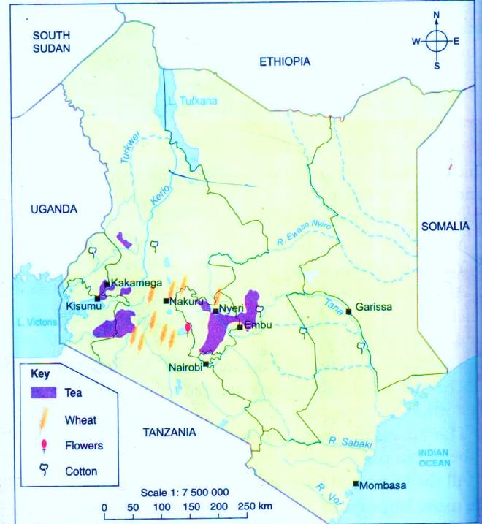
- It is grown on large farms called plantations.
- Maximum height of up 7 metres.
- It is maintained at a height of 0.9 to 1.2 metres for easy picking.
Factors influencing the growing of tea
- A high altitude of between 1529 and 2280 metres above sea level.
- High rainfall of at least 1250mm to 1650mm per year. The rain should be well distributed throughout the year.
- Deep, fertile and well- drained soils. The land should therefore have gentle slopes to allow good drainage.
- Cool temperatures are ideal for the growth of tea.
Areas where tea is grown
- The main tea growing areas in Kenya are: - Kericho, Nandi Hills and Limuru where the crop is grown in large plantations.
- Boet ,Nyamira ,Gucha ,Iment ,Central ,North And Sounth Nyambene Hills ,Nyeri ,Kiambu ,Maragua ,Murang’a North And South And Vihiga Districts.
Importance of Tea
- Processed tea leaves are used to make a drink known as tea.
- Earn the government foreign exchange.
- Source of income for those whom cultivate it.
- Offer jobs opportunities to many people.
- Help in development of infrastructure likes roads and electricity in tea growing areas.
- Help in improved living standard of the people.
WHEAT
- It is a cereal crop.
- It is grown on large farms.
- Kenya does not support wheat because it produces a lot of it.
Factors influencing the growing of wheat
- Fertile soils that are well drained.
- Cool temperatures are ideal for its growth.
- Moderate rainfall is required.
- It requires warm, dry and sunny weather especially during harvesting time.
- It requires gently sloping land to prevent poor drainage of water.
- Areas grown are;
- Nakuru
- Trans-Nzoia
- Londiani
- Laikipia
- Narok
- Timau
- Eldoret
- Naro-Moru
- Kieni West
Importance of Wheat
- Help to make wheat flour used to cook chapattis and mandazi.
- Used in the baking industry to make bread and cakes.
- Help farmers to earn money after the sale.
- Help to offer employment opportunities to many people.
FLOWERS
- Kenya is one of the world’s largest producers of flowers.
- Growing of flowers is called Horticulture.
Types of flower grown
- Roses
- Carnations (Naivasha)
- Daisics
Factors influencing the growing of flowers
- Flowers are mainly grown in special houses called greenhouses where all conditions for growth is controlled e.g. temperature, amount of water.
- Areas where flowers are grown;
- Kiambu
- Thika
- Limuru
- Naivasha
- Eldoret
- Transzoia
- Athi-river
- Timau
- Kieni west
Importance of Flowers
- Help government to earn income
- The farmers also get money from the sale of flowers.
- Create job opportunities
Cotton
- It is a strong and long- lasting fibre used to make clothes.
- Cotton is absorbable of sweet and easy to wash.
- After cotton is harvested .It is first processed in Ginnery where the fibres called lint.
Factors influencing the growing of cotton
- It requires flat and especially when irrigation is done.
- Fertile soil which are well drained.
- Moderate rainfall of between 500 m-1100mm per year.
- Warm temperature of about 25⁰C
- Areas grown is;
- Hola/Bura in Tana river district (under irrigation)
- Kitui ,Imenti south
- Baringo
- Meru central
- Tharaka
- Mbeere
- Teso
- Migori
- Busia district
Importance of Cotton
- Farmers earn money from the sale of cotton.
- Help in growth of textile factories hence create employment.
- Help government to earn foreign exchange
DAIRY FARMING
- This is the keeping of cattle for the production of milk and meat products.
- Small scale farmers keep their animals in enclosed stalls where they are fed and given water Zero grazing.
- Large scale keeps large number of animals and kept it open grazing field and allowed to move freely within the farm. This grazing field is divided into paddock.
Conditions Favouring Dairy Farming
- High and reliable rainfall throughout the year.
- Cool temperature is required.
- Good transport system to ensure quick transportation of milk.
- Continuous and plenty supply of grass and pastures throughout the year.
Areas grown are:-
- Meru
- Murang’a
- Embu
- Nyandarua
- Kirinyaga
- Laikipia
- Nyeri
- Kiambu
- Kisii
- Nyamira
- Nandi
- Eldoret
- Trans-Nzoia
Benefit of Dairy Farming
- Provide us with milk and milk products e.g. butter, cream, yoghurt, ghee and cheese.
- Farmers earn a living from the sale of milk.
- Exportation of dairy products earns revenue for the government.
- Animals help us with manure.
- Creation of employment opportunities on the farm.
- Offer employment opportunities in the dairy farms hence improve living standard of the people.

Problems Facing Dairy Farming
- Drought
- Diseases e.g. Ngana (caused by tsetse flu), east coast fever, foot and mouth.
- Distance from the market- long distance spoil the milk products (perishability)
Perishable good- goods that go bad very fast .Non-perishable goods-goods that can last for many days without going bad.
- Poor roads
- High cost of feeds.
- Low returns
- Mismanagement of co-operative societies.
- Inadequate capital
- Inadequate storage facilities
POULTRY FARMING
- This refers to domestic birds bred for meat and eggs.
- Poultry farming is the practice of raising poultry such as chickens, turkeys, ducks or geese; ostriches give us meat and feathers.
- They are kept for meal and eggs.

Areas where poultry farming is practiced.
- Large scale poultry farming is practiced in Kiambu, Thika, Nairobi, Murang’a because of the availability of a reliable market in Nairobi.
Methods of Poultry Farming
1. Free-Range Poultry Farming
- Another name of this method is backyard rearing.
- This is where bird are reared allowing them to move around freely in search of food and water.
- This method therefore is cheap as little investment terms of housing is required for the poultry.
- Modern poultry farming
- It is a large scale or commercial poultry farming special breeds of chicken are kept for sale.
- Those birds kept for eggs are called layers.
- Those birds kept for mat are called broilers.
- This method is expensive because the chicken needs a lot of care.

Types of modern poultry farming is
- Battery cage
- Deep- litter system
- Fold system
Hatcheries found in Kenya is
- Rift valley hathceris
- Muguku poultry farm
- Kenchic
Benefits of poultry farming
- It is a source of food in the form of meat and eggs.
- It creates employment.
- It is a source of income for the market.
- Poultry droppings are used as manure to increase soil fertility on the farm.
- Feathers from ducks or geese maybe used to make pillows.
Problems facing poultry farming
- Competition from imported eggs and meat.
- Distance from the main markets.
- Loss of products-egg break easily.
- High cost of feeds
- Diseases
- Low productivity
- Lack of skills and knowledge
MINING
- Mineral- is a substance that is naturally found in the earth.
- Mining- is the process of removing minerals or precious materials from the rocks in the ground.
Major minerals mined in Kenya
- Soda-ash
- Limestone
- Fluorspar
- Salt
- Diatomites
- Sand
- Other mined is small amount is gold, silver, sapphire and rubies.
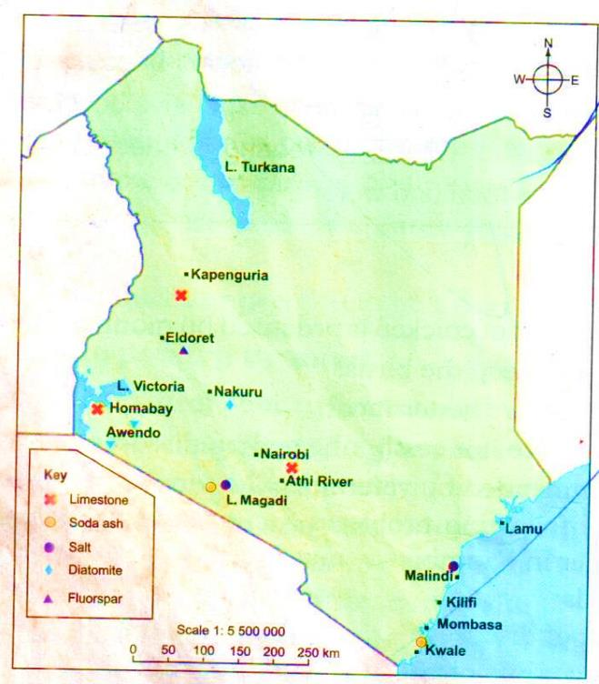

SODA ASH
- It is mined in L.Magadi in Kajiado .
- It is the chief (main) export in Kenya.
- Underground water containing a substance called soda.
- The hard rock that contains salt is called trona.
- Method of mining is Dredge mining- a machine called dredger is used to remove the trona which is then broken and mixed with water. The mixture of trona and water is called slumy.
USES
- Used to make glass, soap, papers, medicine, alluminium, fertilizer and ceramic.
SALTS
- It is mined in L.Magadi .This is mined by directing salty water into the pond where evaporation takes place at the temperature of over 40⁰C
- Salt is also mined at Ngomeni near Malindi from the salty ocean water.

USES
- Add taste
- Used to make soaps
- Used to make glasses.
FLUORSPAR
- It is mined at Kerio valley in the Rift valley near market called Kimwarer.
- The rock containing the mineral is broken with the help of machines or power shovel .The broken piece of the rock are then carried by conveyor belts or trucks to the factory for processing.
This method of mining is called open cast method.
USES
- Used to strengthen steel and alluminium.
- Used to make can
- Used to pack or store tinned products.
- Used in making toothpaste
- Used in oil refining
DIATOMITE
- The main mining area for diatomite is Kariandusi near Gilgil in Rift valley .
- Method used is open cast mining but where the deposit are little deeper, a vertical tunnel or shaft is used to reach them. This method is called shafting mining.
USES
- Used as water filter.
- Used as heat insulator
SAND
- Method used is scooping mining in the riverbed.
- But sometime is obtained by digging horizontal tunnels on hill sides. This is called adit mining.
- Used in building
LIMESTONES
- Is hard rock mined using open cast method.
- It is used to make cement.
- It is mined at Athi river, Bamburi ,Homabay.
USES
- Used to make cement
Importance of mining
- Creation of employment
- Revenue for the government
- Improvement of transport and communication facilities
- Development of social amenities
- Encouragement of trade
FISHING
- Fishing is the harvesting of fish from water for use directly as food at home for sale in local markets or for processing in factories.
- It is done in ocean, lakes ,rivers or ponds.
- Those area where a lot of fish are found and caught are called fisheries
Major fishing grounds
Fishing ground- area where fishing is carried out and it is also called a fishery.
Types of fishing grounds
Marine fishing –it is carried out in ocean in salty water found in sea. It is also called sea fishing.
Inland fishing –It is carried out in fresh water bodies like lakes, swamps ,rivers and fish farms.
Inland fisheries
Most of fish caught in Kenya comes from L.Victoria.
The main fisheries in Kenya are;
1. LAKES
- L. Victoria
- L. Naivasha
- L. Turkana
2. RIVERS
- R. Tana
- R. Yala
- R. Burguret
- R. Miriu
- R. Sagana
- R. Nzoia

- DAMS
- Kiambere
- Masinga
- Young ones of fish are called fingerlings.
- Rearing of fish in a pond is called fish farming.
- Fingering centres are;
- Bamburi
- Sagana in Kirinyaga
- Homa bay in Nyanza
- Fish farming is mainly done in Kisii ,Kirinyaga ,Bamburi

Marine Fisheries
- It is found in the Indian ocean near Mombasa, Malindi ,Shimoni and Vanga.
- The fish are harvested using a big ships called trawlers and is used in deep sea fishing.
Types of Fish Caught
Inland fisheries
Types of fish caught in inland fisheries are;
- Tilapia (Ngege)
- Dagaa (Omena)
- Nile Perch (Mbuta)
- Trout mudfish (Kamongo)
- NB- Tilapia is very common and is found in the lakes in the country.
- NB- Trout is found in fish farms.
- NB- Nile perch is found in L. Victoria and L.Turkana
Marine Fisheries
Types of fish caught are;
- Kingfish
- Parrot fish
- Mullet
- Tuna
- Shellfish like prawns, lobsters, crabs and oysters caught in shallow ocean water close to the land.
Methods of fishing
- Small scale fishing traps and lines are used to catch the fish.
- Commercial fishing (large scale fishing) e.g. trawling, purse-seining and net-drifting
1. Traps
- Traps are used are baskets and gill nets.
- Baskets- this is used conical-shaped basket.
- Gill nets
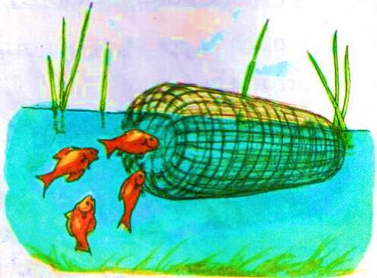
- The hook and line
- String with a hook at the end is tied to a rod. A bait is then put on the hook which is then dipped into the water.

- Long-lining
- This is where several baits are attached to several long lines which are joined to one main line. It is mainly used in marine fishing.

- Trawling
- This involves dragging a net behind a big ship or a boat called a trawler.
- Mainly done in the Indian Ocean.

- Purse-seining
- This is a method where two ships or boats are used dragging a purse like net surrounding a group of fish and create a circular wall all around.
- This is used in lakes and the ocean
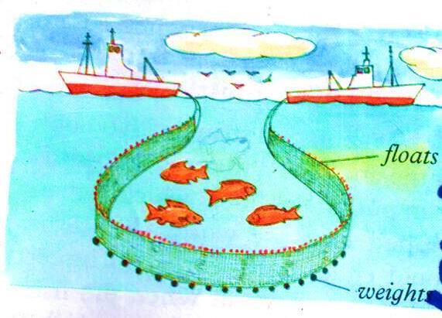
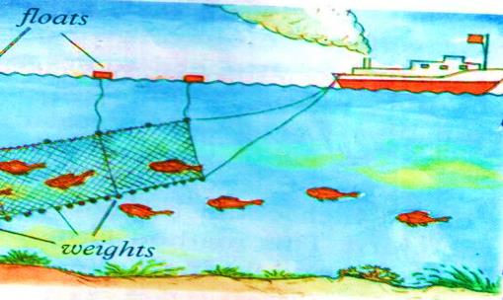

- Net-Drifting
- A net is placed vertically across section of the ocean ,a few metres below the water surface.
- The net is attached to a ship or a boat called a drifter.
Method of preserving fish
- Since fish is a perishable good. Method of preserving fish is made.
Types of preserving is
- Smoking
- Sun drying –it is the cheapest method of preservation
- Canning
- Refrigeration –it is done by freezing hence it is very efficient, put very expensive and can be used only where electricity is available.
FORESTRY
Forestry is the planning and taking care of trees and forests.
Forest- This is a group of trees growing close together on a large piece of land.
Types of Forests
- Natural forests
- Planted forests
Natural Forests
- It consists of indigenous trees growing on their own.
- They are found in highland areas that receive high rainfall.
- It also grows in lowland where moderate rainfall experiences.
- In natural forest.
- Tree grows at different heights.
- There is thick undergrowth
- Different species grow together.
- Trees take long time to mature.
- Trees are hardwoods.
- Examples of hardwood trees are;
- Meru oak
- Mahogany
- Elgon
- Camphor
- Mvule
Planted Trees
- It also called artificial forests.
- It is planted by human beings.
- In planted forest.
- Trees grown are of the same species.
- Trees are planted in rows.
- Trees are mainly softwood.
- Types of trees grown are pine, cypress, eucalyptus are planted.
- There is little or no undergrowth.
- Trees mature faster than those in natural forests.
Distribution of Forests
- Natural forests are found in the following areas;
- Highland forest e.g. Mt. Kenya, Mt. Elgon, Cherangani Hills, Aberdare and Mau ranges and in Kakamega.
- Lowland forests are found along the coast e.g. Arabuko-Sokoke in Kilifi and the forests in Shimba hills.
- Mangrove forests grow in the salty waters on the shores of the Indian Ocean e.g. Lamu, Kwale and Kilifi.
- Planted forest are mainly found in the following areas in Rift Valley e.g. Londiani ,Elburgon ,Kaptagat ,Maji Mazuri ,Turbo ,Timboroa ,Molo ,Burnt forest.

Importance of Forests
- They protect sources of rivers.
- They protect soil from erosion.
- They are a source of firewood.
- They are a source of raw materials.
- They are a home for wildlife.
- They create employment opportunities.
- They help in rain formation.
- They increase soil fertility.
WILDLIFE AND TOURISM
- Wildlife-refers to all wild animals, insects and birds found in their natural surroundings.
- The natural homes for wildlife are called habitats.
Big fives are;
- Elephant
- Lion
- Buffalo
- Rhino
- Leopards
National parks and game reserves
- Area set aside for wildlife is called game park and national parks.
- National park that protect plant and animals that live in water is called marine parks.
- National park is controlled by the government through the Kenya Wildlife Service (K.W.S.)
- Game park are wildlife protection areas in which people are allowed to live and graze their animals.
- Game reserves are mainly managed by the local county councils in which they are located.
National parks and game reserves in Kenya
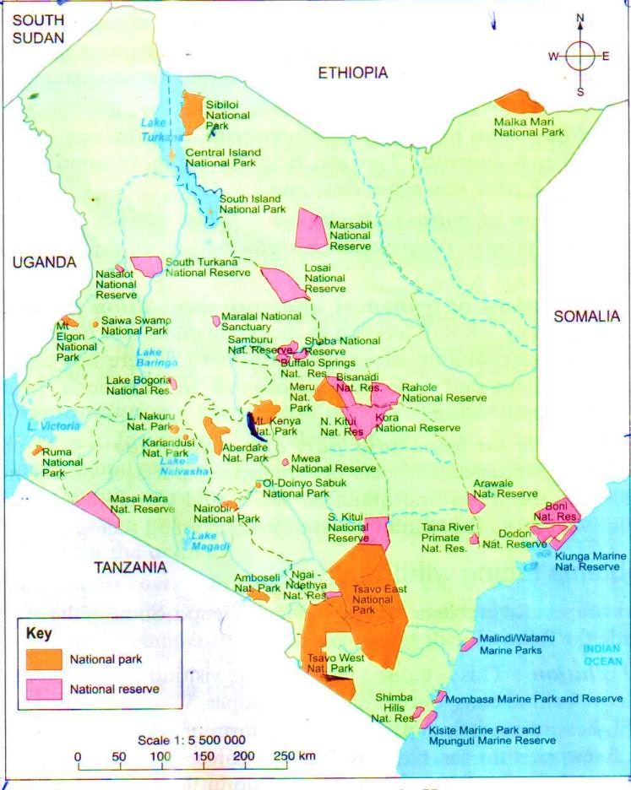
Main National Park in Kenya
- Tsavo east
- Tsavo west
- Amboseli
- L.Nakuru
- Kiunda (marine)
- Kisite (marine)
- Watamu marine
- Mt. Kenya
- Nairobi
- Mt. elgon

Main Game Reserves
- Maasai mara
- Marsabit
- South turkana
- Losai
- Shaba
- Shimba hills
NB- Nairobi national park is the oldest national park in Kenya.
- The largest national park in Kenya is Tsavo national park consist of Tsavo East and Tsavo West and the largest game sanctuary is the world.
- Maasai mara is one of the world’s most famous game reserve .It has big five and it is one of the famous for the wildebeest that migrate from Kenya to Tanzania every year around the month of July.
Importance of Wildlife
- It is a major tourist attraction in Kenya.
- Help to make good use of unproductive lands.
- It creates job opportunities for many people.
- Some wild animals are eaten as food.
- Help to improve international relations.
- Promotion of cultural exchange.
- Development of transport and communication facilities in the country.
- Wildlife is an important part of our heritage.
Problems facing wildlife
- Pollution
- Population increase
- Fire outbreaks in some parks.
- Illegal killings of wild animals (poaching)
- Drought
- Pests and diseases
- Inadequate funds
- Overpopulation
- Increase in cost
Meaning of wildlife conservation
- Refers to efforts being made by individuals and the government to protect and preserve wild animals and plants from damage or destruction.
Effort in Conserving Wildlife
- Establishment of Kenya wildlife service (K.W.S.)
- Banning of hunting of wildlife’s animals and sale of wild animals products e.g. tusks, horns and skins.
- Those products (tusks, horns and skin) are called game trophies.
- Establishment of anti-poaching units to stop poachers from killing wild animals.
- Erecting electric fences around the parks and reserves.
- Establishment of animals orphanage that protect and also care for orphaned and injured animals e.g. Nairobi animal orphanage.
- Establishment of game sanctuaries where the endangered animals are protected.
- Establishment of education on the importance of wildlife and the need to conserve it.
- Establishment of programme of transfer of some animals to avoid overcrowding.
- Improvement of social facilitates of communities living around them.
- Encouragement of game-ranching.
- Establishment of ministry of forests and wildlife.

Meaning of Tourism
- Tourism is a practice of people travelling from their homes to visit and see places and things of interest and to have fun.
- A tourist is a person who travels to places of interest for enjoyment.
Types of tourists
- Foreign tourist
- Domestic tourists
NB- Foreign tourist –are people who travel from their countries to visit places of interest in other countries .They are also called local tourists.
Main tourist attractions in Kenya
- Thing that interest tourists are called tourist attractions
- Wildlife
- Sandy beaches –found in the coast
- Warm climate
- Prehistorically sites, museums, historical sites and monuments e.g. Mnarani ruins and the Gedi rules in Malindi.
- Create monuments include the Vasco da Gama pillar in Malindi.
- Pheristoric sitew are Kariandusi near Gilgil.
Olorrgesailie near L. Magadi
- Koobi for a near L.Turkana
museaum found nationally are;
- Fort Jesus
Kitale museum
- Kisumu museum
- Karen Blixen museum
- Beautiful scenery
- Cultural attractions
- Sports
- Conference facilities e.g. K.I.C.C.
IMPORTANCE OF TOURISM
- Sources of foreign exchange.
- Creates employment opportunities
- Tourism provide a market for locally produced items e.g. carvings, baskets and ornaments (refers to curios)
- Improvements of agricultural sectors hence help to earn income to the farmers.
- Promote good relationship between Kenya with the local people.
- Cultural exchange take places as tourists’ interest interact with the local people.
- Improvement of transport and communication facilities.

Problems Facing Tourism
- Stiff competition from tourist destination in other countries.
- Human-wildlife conflict threatens the existence of wildlife.
- Overdependence on tourists from Europe and America.
- Poor maintenance of some roads leading to Game Park and reserves.
- High entry fees to tourist attraction sites and high visa charges.
- Low earning by potential tourists.
TRADE
- Activity of buying and selling or exchange of goods services between people or countries.
Types of trade
- Barter trade-It was used in the past where people exchange goods by goods.
- Monetary trade (currency trade)- This is where money are used as a medium of exchange.
Main types of trade
- Internal trade
- External trade

Internal Trade
- It involves the exchange of go on and services among the local people within a country.
- It is also called domestic or local trade.
External Trade
- Trade carried out between Kenya and other countries .This trade is also called international or foreign trade.
- The goods and services that Kenya sells to other countries are known as exports e.g. tea, coffee and minerals.
- Goods and services that are bought from other countries by our country are known as imports e.g. fuel, vehicle, lubricants.
Importance of trade
- Trade provides employment opportunities.
- The government earns foreign exchange from exports to other countries.
- Trading activities ensure that goods produced in one part of the country reach the people in other part of the country.
- It helps to promote friendly relations and understanding between the communities in Kenya and other countries.
- Government gets money from traders who pay taxes and fees for trade licenses.
- It helps to promote the development of transport and communication facilities to enable seller and buyers.
- Development of agriculture sectors and other industries.
- Development of urban centres and market centres all over the country.
- Trade encourages the exchange of ideas and information between trading groups.
- Trade enables a country to make use of its resources.
- Trade promotes competition and lowering of prices.
INDUSTRIES
- Industry- is the production of goods from raw materials or processing of raw materials into finished goods e.g. cement is produced from a raw material known as limestone.
- Processing from a raw material often take place in factory.
Types of industries
- Manufacturing industries
- Assembling industries
- Processing industries
- Service industries
Manufacturing industries
- It involve the making of new products from raw materials .Good made don’t undergo other processes.
- Examples are;
- Cement
- Paper
- Textile
- Petroleum
- Glass
- Steel
Processing Industries
- Mostly deal with agricultural raw material.
- Raw materials are processed into finished products which may be used in processed against to make other products.
- Examples are;
Assembly industries
- Used parts that have been produced elsewhere to make new products.
- Major types of assembly industries in Kenya
- Motor vehicle
- Bicycle
- Electronic assembly
Example of Motor Vehicle Assembly in Kenya
- Associated Vehicle Assemblies (AVA) in Mombasa.
- General motors (GM) in Nairobi.
- Cooper Motors Corporation (CMC) in Thika.
- Most of vehicle assemblies in Kenya are imported in Japan and Britain.
- Bicycle parts are mainly imported from India and China.
- Television sets, Computers and radios come from Japan.
Service industries
- These are industries’ that provide services that people and other industries pay for.
Examples are;
- Transport
- Hospitality
- Entertainment
- Hotel
- Bank
- We pay fees for such service that the banks give us.
Some of the industries in this category include the following;
- Repair of motor vehicles, ships, boats, shoes, clothes and electrical machinery.
- Publishing and printing of books, magazines and newspaper.
- Banking and insurance services.
- Tyre repairing
- Hotel services
- Transport and communication service
- The stock market
TRANSPORT AND COMMUNICATION
- Transport is the movement of people or goods from one place to another.
Forms of transport
- Roads (mostly used)
- Railways
- Water
- Air
- Pipeline
ROADS
Types of roads
- Tarmac roads
- All weather loose surface roads (murram road)
- Dry weather roads (earth roads)
Major Tarmac Roads in Kenya Are
- Tran-African highway –starts from Mombasa passes Nairobi, Nakuru and Kisumu before proceeding to Lagos in Nigeria.
- Great North road- is another major road. It starts from Cape Town in South Africa and enters Kenya at Namanga passes Nairobi, Isiolo ,Moyale and goes all the way to Cairo in Egypt.
- Railway transport
- First railway line in Kenya was constructed between 1896-1901 started in Mombasa and ended in Kisumu.
- It passes through Nairobi and other towns like Nakuru and Londiani.
- Branches of railway lines;
- Konza
- Nairobi
- Gilgil
- Kisumu
- Rongai
- Eldoret
- Voi
- Magadi
- Nanyuki
- Nyahururu
- Butere
- Solai
- Kitale
- Taveta
NB- Railway is cheaper than road
WATER TRANSPORT
- Mombasa is the main sea port .It serves Kenya, Uganda, Rwanda ,Burundi ,Sudan and Ethiopia.
Examples of ports in Kenya;
- Mtwapa
- Vange
- Kilifi
- Lamu
- Mombasa
NB- The main inland water transport is mainly practiced on L. Victoria with Kisumu as the main lake port.
Example of port in inland water transport
- Is mainly practiced on L.Victoria with Kisumu as the main lake port. Examples are Kisumu, Homa Bay and Kendu Bay.

AIR TRANSPORT
- It is the fastest means of transport but most expensive.
- It transports people, perishable goods e.g. flowers and valuable goods like jewels.
- Kenya international airports
- Jomo Kenyatta airport (JKIA) in Nairobi
- Moi international airport in Mombasa
- Eldoret international airport in Eldoret
- Small airport are;
- Wilson airport in Nairobi
- Kisumu airport
- Malindi airport
Causes of road accident
Traffic rule- are rules that tell us how roads should be used and are contained in the highway ode.
They are;
- Overspeeding of vehicles
- Unroadworth vehicles
- Overloading of vehicles
- Unqualified or inexperienced drivers
- Careless driving (main cause of road accident)
- Poor roads
- Drug and alcoholic taking while driving.
- Poor usage of road by pedestrian and other road user.
- Poor weather condition
Ways of preventing road accident
- Proper education read to proper use of roads.
- Construction of bump helps to reduce speed.
- Foot bridges, tunnels and pedestrian paths should also be constructed on busy roads.
- Traffic rule should be enforceable to stop over speeding.
- More functional traffic lights should be installed on the roads in major urban centres.
- Correct road signs should be placed at the right places along the roads.
- Punishment of drivers that do not observe traffic rules.
- Vehicle inspection
- Improvement of road by the government
Modern forms of communication
- Communication-is the transfer of information or sending of messages from one person to another or place to another.
Forms of communication
- Courier services e.g. well Fargo, G4s, e.t.c
- Newspapers and magazines (these are print media)
- Telefax
- Telephones
- Postal services
- Radio and television
- Electronic mail (E-mail)
NB- Newspapers and magazine are printed media.
- Telefax, radio, television and email are all referred to as electronic media.
- Examples of radio station
- KBC (Kenya broadcast co-operation)
- Easy FM
- Capital FM
- Kiss FM
- Baraka FM
- Kameme FM
Television Station
- Kenya Television Network (KTC)
- Nation TV( NTV)
- Citizen, Metro (TV)
- Kiss TV
- Family TV
URBANIZATION
- Urbanization is the growth or development of towns and increase in the number of people living in them.
- When an area developed into town is referred to as urban centre.
Major towns in Kenya
- Nairobi
- Eldoret
- Mombasa
- Thika
- Kisumu
- Nakuru
NAIROBI
- Began as railway builders’ depot.
- The builders found Nairobi a suitable place to rest because of its cool climate.
- There was also a lot of fresh water and plenty of flat land.
Factors favouring the growth of Nairobi
- Grew because of railway construction of Mombasa and Nairobi.
- Nairobi had plenty of water and fresh air
- Railway and roads from the surrounding productive area.
- It selected by British during the colonial period as headquarter of the colonial government.
- It is found around agriculturally productive.
- It grew because of the role played by the international community.
- It is established on flat and that is suitable for expansion.
Functions of Nairobi
- Administrative centre
- A major industrial centre.
- A major transport centre
- A major communicate centre
- It is an educational centre
- It is a recreational centre
- It is a tourist centre
- It is a home to international bodies
- It is a major medical centre
- It is a residential centre
- It is a commercial centre
MOMBASA
- It is the earliest towns that grew along the Coast.
- It is the second largest urban centre in Kenya.
Factors favouring the growth of Mombasa
- Influence of early traders to the coast.
- It grew originally due to its location on an island.
- Construction of Kenya-Uganda railway encouraged the growth of Mombasa.
- It has a big hinterland.
- NB- Hinterland –this is the area served by a port.
- It grows due to presence of tourist attractions e.g. fort Jesus, gedi ruins, the sandy beaches and water sports.
- Mombasa is considered as a gateway to eastern Africa.
Functions of Mombasa
- It is a major sea port.
- It is a transport centre
- It is an industrial centre
- It is an administrative centre.
- Is a major tourist centre-Fort Jesus
- It is a cultural centre.
- It is a residential centre
- It is a military centre-headquarter of Kenya navy
KISUMU
- Kisumu city started as a fishing village on shore of L.Victoria.
- It is the largest city in Kenya.
- Found in Nyanza Region.
- Allocated on the Kano plains.
- It is a terminus of the Mombasa-Kisumu railway line.
Factors favouring the growth of Kisumu
- Establishment of railway builders as a lake port.
- It has a rich hinterland which has fertile soil for agriculture.
- L. Victoria is a rich source of fish that encourage settlement of people in the town.
- The colonial government made Kisumu an administrative centre.
Functions of Kisumu
- It is an administrative centre-it’s headquarter of Kisumu city.
- It is a major port because of L. Victoria hence it is the largest inland port.
- It is an industrial centre.
- Kisumu is a major fishing area.
- It is a trading centre.
- It is a regional centre-regional town of people of western Kenya.
- It is a transport centre-there is airport, railway line, roads.
- It is an educational centre e.g. Maseno University, Kisumu colleges, polytechnics, secondary and primary.
- It is a residential centre.
ELDORET
- It is located in a rich agricultural area.
- It started as a market and collection centre for agricultural produce from the surrounding area.
- T is found in the rift valley region of Kenya.
- It is located along the Nakuru-Malaba railway line and the Nakuru-Kitale road.
Factors favouring the growth of Eldoret
- It has rich agricultural background.
- Establishment of Moi University also contributes in the growth of town.
- Government policy of expanding facilities to other towns away from Nairobi led to establishment.
Functions of Eldoret
- It is an agricultural centre.
- It is a transport centre.
- It is an educational centre.
- It is a residential centre
- It is a medical centre
- It is a commercial centre
- It is an industrial centre
- It is a communication centre
THIKA
- Thika town started as an agricultural market centre but grew as an industrial centre.
Location of Thika
- It is in the central region of Kenya.
- It is located to the north-east of Nairobi city along R. Thika and R. Chania.
Factors favouring the growth of Thika
- It started as an agricultural centre.
- Encouragement of government policy to relocate industries away from Nairobi.
- It is located on a flat area which is suitable for expansion.
- Supply of water from rivers (Thika, Chania) which encourage settlement.
- It is good resting place (spot) between upcountry and Nairobi from the settlers.

Functions
- It is a major industrial centre
- It is an administrative centre
- It is an agricultural centre
- It is a tourist centre
- It is an educational centre
- It is a residential centre
NAKURU
It is the fourth largest urban centre.
It started as a settlement area for the railway builders and collection centre for agricultural produce.
Location of Nakuru
- Found in rift valley region of Kenya.
- Located on a narrow stretch of flat land between L. Nakuru and Mt. Menengai.
- It is near Mau escarpment and on the shores of L. Nakuru.
Factors favouring the growth of Nakuru
- It is rich in agricultural produce.
- It is centrally positioned at major highways in Kenya.
- The towns Neighbours L. Nakuru National Park which attract tourists

Functions of Nakuru
- It is a railway junction centre.
- It is a transport centre.
- It is a tourist centre.
- It is a commercial or trading centre.
- It is an industrial centre.
- It is an agricultural centre.
- It is an administrative centre –headquarter of Nakuru County.
- It is an agricultural equipment supply centre.
- It is an educational centre.
- It is a residential centre.
POLITICAL DEVELOPMENT AND SYSTEMS
Political system- Refers to the way a group of people is organized and governed.
Contributions of prominent traditional leaders in Kenya
MASAKU
Contributions
- He was a descendant of Kivoi.
- He was a great prophet among the Akamba people.
- He prophesied about the construction of the railway in the area, he said about the coming of a long snake to their land.
- He was a medicine man who treated people using herbs.
- He explained the meanings of certain events to the people.
- He offered guidance and advice to traders who were long distance traders.
- He told people about coming of European in the area.
- He took part in the long distance trade and controlled it in his area.
- NB- Masaku died in Kangundo in 1904.
KOITALEL ARAP SOMEI
- He was a Nandi brave and powerful leader or Orkoiyot.
- He was a military and prophet leader too.
- Became Orkoiyot in 1895.
Contribution of Samoei (Orkoiyot)
- He led the Nandi community in resisting colonial rule (British)
- He led his people in fighting against the construction of the railway line on their land.
- He was a spiritual leader and prophet too. He prophesied about the construction of railway and colonization.
- He was a medicine man
NB- Samoei was later captured by the British and shot dead.
MEKATIMU WA MENZA
- 1895-1913 European had taken a lot of land from people of the coast.
- They had tried to remove Giriama from their land settlement in R. Sabaki so that they could settle there.
- European interferes with the place of worship of Giriama called Kaya.
- Heavy taxation was introduced.
- All these made the Giriama very angry.
- In 1913 Giriama prophetess called Mekatilili wa Menza led people to repel against British.
- They attacked European settlement and trade passing through their land.
- Mekatilili was arrested and deported to Gusii land.
- After this happened Giriama lost their political power.
Contributions of Mekatilili wa Menza
- He led Giriama to fight British.
- She resisted the introduction of colonial rule among Giriama.
- She was a prophetess and a political leader.
- She administered oaths among the Giriama.
Traditional forms of government
The outstanding individuals
- Kings
- Chiefs
- Groups of individuals
- This groups of individuals usually formed the council of elders.
- Where community was led by a king is called kingdom while that led by chief is called chiefdom.
The Abawanga
- Abawanga of wanga of the western Kenya.
- Form a government called Kingdom.
- The title of the king is called Nabongo.
- The position of Nabongo was hereditary (family leadership)
- The Nabongo had a big army called Olukuyaba.
- One famous Nabongo of the Wanga kingdom was Munia who became Nabongo in 1879 after the death of his father Shiundu.
The Ameru
- The system of leadership was based on age set system.
- The two age-set are Kiruka and Ntiba were by headed by council of leders.
- The ceremony held for handling power after 12-15 years is called Ntuiko.
- The generation of power had a council of elders called Njuri Ncheke.
Functions of Njuri Ncheke
- Maintaining a smooth system of resolving conflicts.
- Safeguarding the religious values of the community.
- Deciding kind of traditional education to pass to the children .
- Ensuring security of the community is safeguard.
- Advising of on the best economic activities.
NB- Difficult matters were being settled by small inner council group called Njuri Imperee.
- People found guilty of an offence were forwarded to elders known as Nkomango.
- The Ameru had a religious leader whose title was Mugwe.
Responsibilities of not Mugwe as religious leader
- Blessing major events e.g. sacrifices.
- Declaring things that were taboo and prohibited.
- Declaring curses when age-sets being promoted.
NB- Decisions made by Mugwe and council of elders were respected therefore enhances peace and unity among the Ameru.
Role of traditional forms of government
- They settled disputes among communities.
- They punished wrong doers.
- They ensured law in a community was followed.
- They conducted religious ceremonies led by religious leader.
Establishment of colonial rule in Kenya
- The first groups to arrive in Kenya were explorers, missionaries and British followed.
- British arrived in Kenya the first time in 1888.
- The trading company called IBEAC (Imperial British East Africa Company) led by William Mackinnon.
- 1895, Kenya became a British protectorate.
- Kenya was ruled by British government representative entitled commissioner.
- 1907, the first Legislative Council (Legco) kind of parliament in Kenya was established.
- The title of commissioner to governor.
- The first governor in Kenya was called colonial Sir James Hayes Sadler.
- Kenya was declared a British colony in 1920.
- Colonial administration in Kenya was headed by a governor represent the king of England.
- Africans who were loyal to the government were appointed as chief and headmen.
African response to colonial rule
- Some communities resisted while others collaborated.
Example of resistance
- The Nandi
- The Ababukusu
The Nandi
- It was led by Koitalel Arap Samoei
Reasons why they resisted British
- Fear to lose their land.
- They do not want railway to pass their land because Kimyole Arap Turkal passing through their land since he was a prophet.
- Because British discouraged some traditional practices to like cattle raiding which was very important.
- Nandi did not want to be ruled by outsiders.
NB- Between 1895-1905 the Nandi fought many battle with the British.
Reasons why they were able to resist the British;
- They were strongly united.
- They were well trained.
- They wanted to prove to the other community that they have strongly leadership (power)

THE ABABUKUSU
- Occupied slope of Mt. Elgon
- Ababukusu refused to surrender their independence to Mumia and British.
- IBEAC wanted Ababubukusu to defeat and made to obey Mumia.
Reasons why Ababukusu resisted the British
- They could not surrender their independence to Mumia since he was their enemy.
- They wanted to protect their land.
- They valued their culture.
COLLABORATION
They were;
- Nabongo Mumia
- Chief Waiyaki
Nabongo Mumia
- He was a leader of Abawanga of Western Kenya
He welcomed the British in his kingdom of the following reasons;
- He thought the British were not going to stay for long.
- He helped that he is going to be helped by British to overrule neighbouring communities.
- He wanted British to protect him from his enemies.
NB- As a reward for supporting them, the British recognized Mumia as the ruler of that region.
- 1906 ,Mumia power was reduced by British to that of ordinary chief.
- 1909, Mumia was declared paramount chief of Wanga people.
- By the time he died in 1949 being a frustrated man.
Waiyaki Wa Hinga
- He was a collaborater as well as resistor.
- He ruled Dagoretti area of Kiambu.
- He welcomed British officer called captain Lugard.
- Lugard built a fort because it was a good place.
- British officer who were sent in Machakos after Lugard continued in Uganda disrespect Waiyaki led by Eric Smith and they built another fort at Kabete which named Fort Smith and left some of his officer incharge.
- When Waiyaki asked about Fort Smith he was beaten by British officer and he was prisoned at Mombasa for trial.
- Two day later Waiyaki died at Kibwezi on the way to Mombasa.
CITIZENSHIP
Citizen- Is a person who belongs to a particular country.
Citizenship –Is therefore the state of being a member of a given country.
Way of becoming a Kenya citizen
- Birth
- Registration
- Dual citizenship
By Birth
- A person born of Kenya parents in Kenya naturally becomes a Kenya citizen.
- A person born outside Kenya can become a Kenya citizen if one of the parent is a Kenya citizen at the time of birth. E.g. a child of eight years or below who is found in the country and whose parents are not known is taken to be a citizen by birth.
By Registration
- A person who was born outside Kenya and has attained 21 years may apply to be registered as a citizen of Kenya if he/she satisfies the following conditions;
- If one of parent is a citizen of Kenya.
- If he/she has been living in Kenya for a period of at least 7 years.
- Adequate knowledge of Kiswahili and English.
- Should have a good character of citizen.
- E.g. a child who is not a citizen of Kenya but has been adopted by a Kenyan citizen shall be registered upon applicant.
- A person who has been married to a Kenyan citizen for at least seven years can also apply to be registered as a citizen of Kenya.
Responsibilities of a Kenyan citizen
- A responsibility- Is a duty that a person is expected to perform.
- Obeying the law
- Voting
- Paying taxes
- Taking care of the environment
- Taking part in development activities
- Being fair and honest
- Being loyal and patriotic
- Showing respect
Importance of go of citizenship
- Government is able to govern people easily.
- Government is able to start and continue development programmes.
- It helps people to work freely without fear.
- Help to raise the living standard of the people.
- All citizen are treated fairly
- It helps to promote patriotism.
- It helps to promote peace, love and unity.
- Help to get good leader by voting
DEMOCRACY AND HUMAN RIGHT
Definition: government rules according to the wishes of people and benefit of the people
Types of Democracy
- Direct or participatory democracy
- Representative or parliamentary democracy
- Delegative democracy
- Nominational democracy
- Liberal democracy
Direct Democracy
- It is also known as participatory democracy
- Individuals of organized group are involved in making decision on various issues that concern them e.g. Kenya government
Representative Democracy
- Also known as parliamentary democracy.
- People select people to represent and make decision on their behalf e.g MP ,Councilors
FORMS OF CHILD ABUSE
Dfn; is anything done to a child which will harm the child or affect the child’s safety and healthy development
- Killing of a child
- Beating
- Overworking the child
- Abandoned
- Excessive caning or harsh punishment
- Use of harsh and abusive language against the child
- Bullying
- Forced marriage
- Displacement Child (FGM)
- Girl circumcision
- Denying the child food and clothes
- Insulting the child
- Raping
- Sodomizing
Ways of protecting children from abuse
- Educating parent and society about need for child protection.
- Establishing rescue centres
- Providing counseling services to victims of abuse.
- Encouraging child to report any cases of abuse either home or school.
- Providing medical care to children who have been abused.
- Giving stiff punishment to child abusers.
- Encouraging other people to report cases of child abuser.
- Educating children on their rights.
- Reviewing and enforcing relevant policies and law that protest children.
LAW, PEACE AND CONFLICT SOLUTION
Dfn; rule help people live peacefully in the country is called laws.
CAUSES OF LAWLESSNESS
Dfn; lawlessness is a state where the laws of the country are not respected.
Factors led to lawlessness
- Poverty
- Tribalism
- Nepotism
- Religious differences
- Lack of employment opportunities
- Corruption
- Unequally among the citizens.

Effect of lawlessness
- Condition led by shortage of food in the society.
- People live in fear
- Insecurity leading to destruction of property and loss of lives
- It makes difficulty of the government to provide social services and facilities e.g. schools, hospitals e.t.c.
- Tourists stops visiting the country
- Companies will not invest their capital
Importance of the rule of law
People live in peace because of;
- The law is applied fairly
- Wrongdoers are arrested and punished.
- People respect one another and their property.
- People support and help each other.
- Children are also able to go to school safely.

THE GOVERNMENT OF KENYA
The arms of government
- The Legislature
- The Executive
- The Judiciary
Composition of the arms of the government
The legislature
- Is a body that make and amends laws.
- It is also called parliament
Composition of parliament
- The national assembly
- The senate
Composition of the National Assembly
According to the new constitution of Kenya national assembly has;
- 290 elected members representing the constituencies.
- 47 elected women representing each county.
- 12 members nominated by the political parties.
- The speaker, who is an ex-officio member

Composition of the Senate
- 47, elected members, each representing a county.
- 16 women members nominated by the political parties.
- Two youth representing people ( male & female)
- Two members representing people with disabilities.
- The speaker, who is an ex-officio member.
THE EXECUTIVE
- It makes and implements governments’ policies.
- Make sure that the laws passed by parliament are observed.
Composition of the Executive
- The president- is the head of state and government and the commander-in-chief of Kenya Defence forces.
- The deputy president-; - is the chief assistance of the president .He or she can perform various functions on behalf of the president.
- The cabinet-it is made up of ;
- President
- Deputy President
- Attorney General
- Cabinet Secretary
- The cabinet secretaries range from 14-22 members.
- This depend on the member of state departments (ministries) created
- People working for government and help to implement policies are also part of executive(civil servants)
- NB; The secretary to the cabinet is appointed by president with an approval of national assembly.
- Principle secretary is in charge of a state department (ministry)
THE JUDICIARY
- It administer (interpret) justice through a system of courts.
- It is headed by chief justice who is appointed by the president.
Composition of the Judiciary
- The chief justice –the head of judiciary.
- The deputy chief justice
- The chief registrar of the judiciary. This is the chief administration and accounting officer of the judiciary.
- Judges of the superior court
- Magistrates
- Other judicial officers and staff
- The judicial service commission
Composition of the independence electrol and boundaries commission.
- The commission in in charge of organizing national election and reverend.
- It is also charged with reviewing the names and boundaries of constituencies .
It consists of:-
- A chairperson- Isaac Hassan
- A chair person
- A minimum of one and a maximum of seven others members.
- A secretary appointed by the commission.
NB- The secretary is in charge of day-to-day administration of the commission.
NB- The chairperson should not be of the same gender (male & female)

